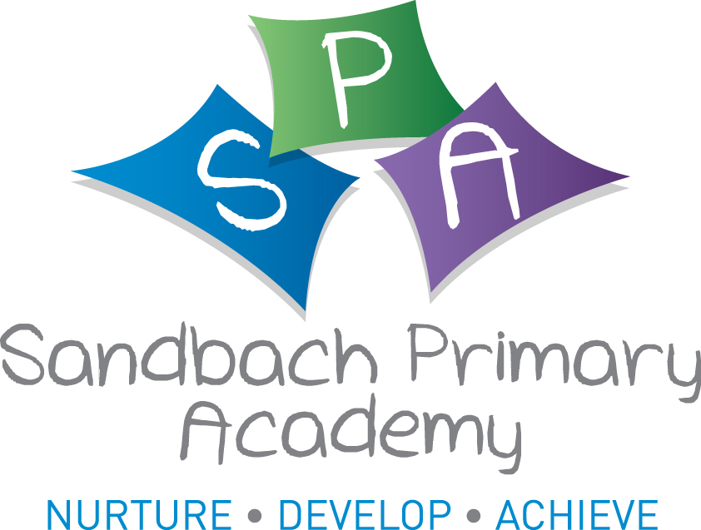



Sandbach Primary Academy
Home Learning
Class Nursery Date 11th December

Area of Learning | Activities | Resources
Literacy | Share the story of  ‘Goldilocks and the Three Bears.’  Tell your grown-up about who is in the story. Retell the story together.  You might like to use some toys to help you. Try using different voices for each bear. Remember what happened first, next, at the end. | Mr Tumble's Storytime | Goldilocks and The Three Bears | Mr Tumble and Friends (youtube.com)
Phonics –  pre-school | Last week, we were listening for the initial phoneme (sound) ‘o’. We had an ‘ostrich’, ‘orange’ ‘otter’ and ‘octopus’ in our box. Play a game where you put three or four items in a box / bag / under a cloth.  They might start with the same phoneme e.g. bear, ball, button.  Encourage your child to listen for the phoneme and support them saying it.  If they are finding this hard, go on a hunt together around the house. ‘I spy, with  my little eye, something starting with  the phoneme ‘c’.’ What can you find?
Mathematics | In the story, we learnt that the bears were different sizes.  Younger children might like to find things around the house, garden, town, that are ‘big’ or ‘small’.  Pre-school children can find three or more items and order them. Try finding items that are the same but different sizes e.g. spoons, leaves, stones, shoes.  Talk about ‘biggest’, ‘smallest’, ‘bigger than/smaller than.’
Wider Curriculum | Expressive arts and design-  We watched the ‘Goldilocks Ballet’ on BBC i-player. We noticed how the dancers showed how they were feeling through their movements. Watch it again and join in with the dancing, or make your own dance. How would you feel if someone had broken your chair?  Understanding the World - Talk about how you, and people you know, are getting ready for Christmas. Ask your grown-up, how they celebrated Christmas when they were little.  You might like to take a photo of a favourite decoration or tree. | BBC iPlayer - Goldilocks and the Three Bears: A CBeebies Ballet

