Year: 5/6 A | Autumn 1 | Autumn 2 | Spring 1 | Spring 2 | Summer 1 | Summer 2
Book  (Main Driver Text) | Beowulf  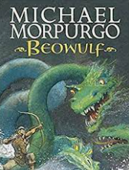 | 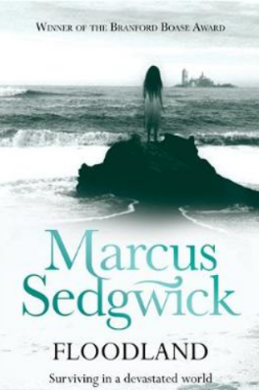  Floodland | The Sleeper and the Spindle  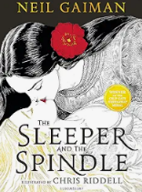  New and Collected Poems for Children  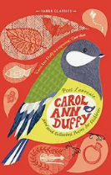 | The Brockenspectre  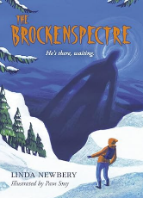  Survivors  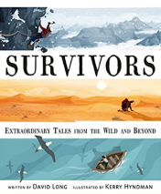 | The Matchbox Diary  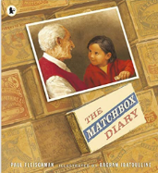  A Story Like the Wind  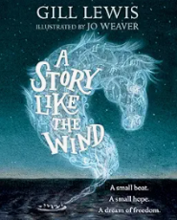 | Kensuke’s Kingdom  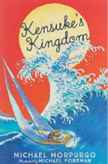  The Lady of Shallot  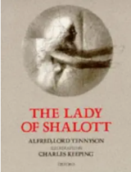
Author | Michael Morpurgo or  Kevin Crossley-Holland | Marcus Sedgwick | Neil Gaiman  Carol Ann Duffy | Linda Newbery  David Long | Paul Fleischman  Gill Lewis | Michael Morpurgo  Tennyson/Keeping
Theme | Anglo-Saxons | Coastal settings/water | Vikings | Survival | Migration | Water/Islands
Literary form | Classic fiction | Modern fiction (Sci-fi) | Narrative (myths) | Non-fiction | Picture Book | Narrative (adventure)
Writing Outcomes | Character description  Diary entry | Narrative  Persuasive letter  Speech | Narrative – alternate ending  Biased essay | Non-chronological report  Retelling of a real event  Blog | Letter – persuasion  Balanced argument  Narrative - flashback | Brochure  Jingle  Letter – persuasion  Explanation
Composition | Year 5  Plan:  • use other similar writing as models for their own  • in writing narratives, consider how authors have developed characters, settings and atmosphere in texts they have read, listened to or seen performed  • identify the audience for and the purpose of the writing  • begin to use a variety of approaches to support effective planning  • note and develop initial ideas, drawing on reading and research where necessary  • rehearse orally, alternative word choices and sentence constructions to best suit the purpose and effect of a text (National Curriculum English Appendix 2)  Draft and write:  • experiment with form in narrative writing  • adapt writing to distinguish between the language of speech and that of written texts.  • maintain an appropriate balance between dialogue and narrative  • develop some aspects of characterisation through what characters say and do, beginning to integrate this within a text  • begin to weave in setting descriptions with characterisation and action  • write in a range of genres and forms taking account of different audiences and purposes e.g. in personal recounts; in diary form; formal and informal letters; balanced and one sided arguments  • organise information gained from notes made from reading into own writing  • begin to précis longer paragraphs from reading e.g summarising a series of paragraphs; identifying the key points within a longer paragraph; identifying the content words within a paragraph. In this paragraph, the writer gives us a detailed description of the war-torn town, describing the destruction of homes and shops. In the next paragraph we find out more about the people of the town and what they are going to do next  • use a range of organisational and presentational devices to structure text and guide the reader  • prepare poems to read aloud and perform  • learn a wider range of poetry by heart  • experiment with writing poetry using different forms  • organise ideas so that they are sequenced logically according to the genre or form, using a range of adverbials and conjunctions (see vocabulary / grammar section for detail of year group expectations)  • use expressive and figurative language to create mood and atmosphere  • begin to make choices about vocabulary, word order, and punctuation for effect.  • begin to consciously control sentence structures in their writing, sometimes making choices about, sentence length, sentence complexity and punctuation for effect.  • engage reader and sustain interest, in both narrative and non-fiction writing, building on examples provided in year 4 such as asking questions / addressing the reader directly  • begin to develop points of view and authorial voice  • begin to structure main ideas across the text by using paragraphs purposefully  • use devices to build cohesion within a paragraph  • link ideas across paragraphs using adverbials of time  • begin to use paragraphing to deliberately pace the writing  Evaluate and edit:  • proof read for spelling, grammar and punctuation errors  • re-read to check that their writing makes sense, that tenses are consistent, pronouns are used accurately, and that there is correct subject and verb agreement when using singular and plural  • evaluate and edit, assessing the effectiveness of their own and others’ writing  • propose changes to vocabulary, grammar and punctuation to enhance effect and clarify meaning  • perform their own compositions, using appropriate intonation, volume, and movement so that meaning is clear  Year 6  Plan:  • use other similar writing as models for their own  • in writing narratives, consider how authors have developed characters, settings and atmosphere in texts they have read, listened to or seen performed  • identify the audience for and the purpose of their writing and select the appropriate form when planning  • use a variety of approaches to support effective planning  • note and develop initial ideas, drawing on reading and research where necessary  • rehearse orally, alternative word choices and sentence constructions to best suit the purpose and effect of a text (National Curriculum English Appendix 2)  Draft and write:  • use a variety of narrative structures  • adapt writing to distinguish between the language of speech and written texts and choose the appropriate register (formal/informal, personal/impersonal)  • blend elements of dialogue, action and description appropriately, ensuring a balance between dialogue and narrator  • include aspects of characterisation, including what characters say and do, integrating this within a text  • weave in setting descriptions with characterisation / action  • build on previous year groups’ use of organisational and presentational devices to structure text and guide the reader  • prepare poems to read aloud and perform  • learn a wider range of poetry by heart  • write poetry using different forms  • make organisational choices for effect, according to the genre or form, using a range of adverbial phrases and conjunctions (see vocab grammar section for detail of year group expectations)  • use expressive and figurative language to create mood and atmosphere  • select suitable punctuation and precise vocabulary when writing.  • consciously control sentence structures in writing, making deliberate choices about sentence length, sentence complexity and punctuation for effect. • maintain interest for the reader in a variety of ways in both narrative and non-fiction writing  • develop points of view and authorial voice  • structure main ideas across the text by using paragraphs purposefully  • use paragraphing to deliberately pace the writing  Evaluate and edit:  • proof read for spelling, grammar and punctuation errors  • re-read to check that their writing makes sense, that tenses are consistent  • use pronouns accurately, with correct subject and verb agreement when using singular and plural  • evaluate and edit, assessing the effectiveness of their own and others’ writing  • propose changes to vocabulary, grammar and punctuation to enhance effect and clarify meaning  • perform their own compositions, using appropriate intonation, volume, and movement so that meaning is clear
Grammar | Year 5  • use a variety of sentences structures,  • e.g. single clause sentences  • and multi-clause sentences using coordinating conjunctions  • and multi-clause sentences using subordinating conjunctions  • use the full range of punctuation taught across KS1 and LKS2 to demarcate sentences, including apostrophe use and speech punctuation  • use brackets, dashes or commas for parenthesis e.g. asides, additional information  • place commas, mostly accurately, to clarify meaning or avoid ambiguity  • use a range of conjunctions, prepositions and adverbials  • use relative clauses beginning with who, which, where, when, whose, that or an omitted relative pronoun  • begin to make precise and effective use of expanded noun phrases, conveying complicated information concisely  • use Standard English forms for verb inflections instead of local spoken forms  • learn the grammar for Y5 from English Appendix 2  • maintain tense consistently and begin to manage shifts in tense  • use the perfect form of verbs to mark relationships of time and cause  • indicate degrees of possibility using adverbs  • ensure correct subject and verb agreement when using singular and plural  • begin to use pronouns and a variety of nouns appropriately to aid cohesion and avoid repetition  • use and understand the grammatical terminology found in English Appendix 2 in discussing their writing  Year 6  • use a variety of sentence structures, such as: single clause sentences  • and multi-clause sentences using coordinating conjunctions  • and multi-clause sentences using subordinating conjunctions  • use the full range of punctuation taught across KS1 and KS2 to demarcate sentences, including apostrophe use and speech punctuation  • use hyphens to avoid ambiguity  • understand the use of semi-colons, colons and dashes to mark the boundary between independent clauses  • use a colon to introduce a list  • punctuate bullet points consistently  • place commas to demarcate items in a list, between clauses and to clarify meaning or avoid ambiguity  • use a range of conjunctions, prepositions and adverbials  • use relative clauses beginning with who, which, where, when, whose, that or an omitted relative pronoun  • make precise and effective use of expanded noun phrases, conveying complicated information concisely  • use Standard English forms for verb inflections instead of local spoken forms  • maintain tense and person consistently including shifts between tenses  • use the perfect form of verbs to mark relationships of time and cause  • use modal verbs to indicate degrees of possibility and when deducing, speculating, and making suppositions  • use passive constructions where appropriate  • use pronouns and a variety of nouns appropriately to aid cohesion and avoid repetition  • use and understand the grammatical terminology found in English Appendix 2 accurately and appropriately when discussing their reading and writing
Handwriting | Year 5  • write legibly, fluently and with increasing speed  • choose the writing implement that is best suited for a task  • choose which shape of a letter to use when given choices and deciding whether or not to join specific letters e.g. using un-joined script for captions; diagram labels; headings in non-fiction; slogans in posters; filling in a form; in algebra  Year 6  • write legibly, fluently and with increasing speed  • choose the writing implement that is best suited for a task  • choose which shape of a letter to use when given choices and decide whether or not to join specific letters e.g. using un-joined script for captions, diagram labels, headings in non-fiction, slogans in posters, filling in a form, in algebra
Transcription | Year 5  • use the first three or four letters of a word to check spelling, meaning or both of these in a dictionary  • use dictionaries to check the spelling and meaning of words  • use a thesaurus to select precise and effective vocabulary  • spell most words relating to the statements from previous year groups correctly, after independent proof-reading  • spell some words relating to the Y5/6 curriculum statements and word lists correctly, after independent proof-reading  Year 6  • use the first three or four letters of a word to check spelling, meaning, or both of these in a dictionary  • use dictionaries to check the spelling and meaning of words  • use a thesaurus to select precise and effective vocabulary  • spell most words relating to the statements from previous year groups correctly, after independent proof-reading  • spell most words relating to the Y5/6 curriculum statements and word lists correctly, after independent proof-reading
Cross curricular reference | Anglo-Saxons and Scots  Animals including Humans | UK Coasts  Animals including Humans | Vikings  Electricity | UK Mountains | Mayan civilisation  Light | Europe – Economic Activity  Evolution and Inheritance

Year: 5/6 B | Autumn 1 | Autumn 2 | Spring 1 | Spring 2 | Summer 1 | Summer 2
Book  (Main Driver Text) | Stay Where you are and Then Leave  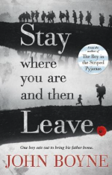 | Clockwork  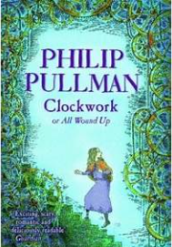 | 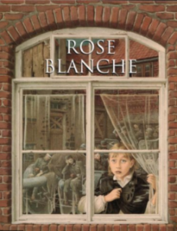  Rose Blanche | 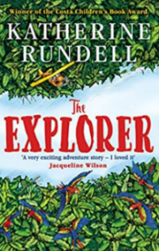  The Explorer | 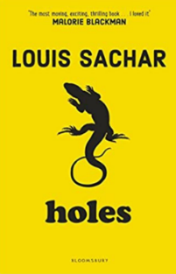  Holes | 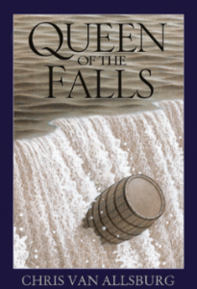  Queen of the Falls
Author | John Boyne | Philip Pullman | Ian McEwan | Katherine Rundell | Louis Sachar | Chris Van Allsberg
Theme | WW1 | Horror/Suspense | WW2 | Adventure/South America | Crime and Punishment | North America
Literary form | Poetry | Narrative | Picture Book | Narrative | Picture Book | Classic narrative
Writing Outcomes | Poetry lyrics and performance  Balanced argument  Narrative - setting | Narrative – horror/gothic  Biased essay  Explanation | Speech  Political pamphlet  Narrative – cliffhanger  Recount of a real event (residential) | Narrative – adventure  Instructions  Comparison Guidebook  Narrative poem | Narrative  Persuasive letter  Poetry (free verse)  Blog | Biography  Non-chron report  Autobiography
Composition | Year 5  Plan:  • use other similar writing as models for their own  • in writing narratives, consider how authors have developed characters, settings and atmosphere in texts they have read, listened to or seen performed  • identify the audience for and the purpose of the writing  • begin to use a variety of approaches to support effective planning  • note and develop initial ideas, drawing on reading and research where necessary  • rehearse orally, alternative word choices and sentence constructions to best suit the purpose and effect of a text (National Curriculum English Appendix 2)  Draft and write:  • experiment with form in narrative writing  • adapt writing to distinguish between the language of speech and that of written texts.  • maintain an appropriate balance between dialogue and narrative  • develop some aspects of characterisation through what characters say and do, beginning to integrate this within a text  • begin to weave in setting descriptions with characterisation and action  • write in a range of genres and forms taking account of different audiences and purposes e.g. in personal recounts; in diary form; formal and informal letters; balanced and one sided arguments  • organise information gained from notes made from reading into own writing  • begin to précis longer paragraphs from reading e.g summarising a series of paragraphs; identifying the key points within a longer paragraph; identifying the content words within a paragraph. In this paragraph, the writer gives us a detailed description of the war-torn town, describing the destruction of homes and shops. In the next paragraph we find out more about the people of the town and what they are going to do next  • use a range of organisational and presentational devices to structure text and guide the reader  • prepare poems to read aloud and perform  • learn a wider range of poetry by heart  • experiment with writing poetry using different forms  • organise ideas so that they are sequenced logically according to the genre or form, using a range of adverbials and conjunctions (see vocabulary / grammar section for detail of year group expectations)  • use expressive and figurative language to create mood and atmosphere  • begin to make choices about vocabulary, word order, and punctuation for effect.  • begin to consciously control sentence structures in their writing, sometimes making choices about, sentence length, sentence complexity and punctuation for effect.  • engage reader and sustain interest, in both narrative and non-fiction writing, building on examples provided in year 4 such as asking questions / addressing the reader directly  • begin to develop points of view and authorial voice  • begin to structure main ideas across the text by using paragraphs purposefully  • use devices to build cohesion within a paragraph  • link ideas across paragraphs using adverbials of time  • begin to use paragraphing to deliberately pace the writing  Evaluate and edit:  • proof read for spelling, grammar and punctuation errors  • re-read to check that their writing makes sense, that tenses are consistent, pronouns are used accurately, and that there is correct subject and verb agreement when using singular and plural  • evaluate and edit, assessing the effectiveness of their own and others’ writing  • propose changes to vocabulary, grammar and punctuation to enhance effect and clarify meaning  • perform their own compositions, using appropriate intonation, volume, and movement so that meaning is clear  Year 6  Plan:  • use other similar writing as models for their own  • in writing narratives, consider how authors have developed characters, settings and atmosphere in texts they have read, listened to or seen performed  • identify the audience for and the purpose of their writing and select the appropriate form when planning  • use a variety of approaches to support effective planning  • note and develop initial ideas, drawing on reading and research where necessary  • rehearse orally, alternative word choices and sentence constructions to best suit the purpose and effect of a text (National Curriculum English Appendix 2)  Draft and write:  • use a variety of narrative structures  • adapt writing to distinguish between the language of speech and written texts and choose the appropriate register (formal/informal, personal/impersonal)  • blend elements of dialogue, action and description appropriately, ensuring a balance between dialogue and narrator  • include aspects of characterisation, including what characters say and do, integrating this within a text  • weave in setting descriptions with characterisation / action  • build on previous year groups’ use of organisational and presentational devices to structure text and guide the reader  • prepare poems to read aloud and perform  • learn a wider range of poetry by heart  • write poetry using different forms  • make organisational choices for effect, according to the genre or form, using a range of adverbial phrases and conjunctions (see vocab grammar section for detail of year group expectations)  • use expressive and figurative language to create mood and atmosphere  • select suitable punctuation and precise vocabulary when writing.  • consciously control sentence structures in writing, making deliberate choices about sentence length, sentence complexity and punctuation for effect. • maintain interest for the reader in a variety of ways in both narrative and non-fiction writing  • develop points of view and authorial voice  • structure main ideas across the text by using paragraphs purposefully  • use paragraphing to deliberately pace the writing  Evaluate and edit:  • proof read for spelling, grammar and punctuation errors  • re-read to check that their writing makes sense, that tenses are consistent  • use pronouns accurately, with correct subject and verb agreement when using singular and plural  • evaluate and edit, assessing the effectiveness of their own and others’ writing  • propose changes to vocabulary, grammar and punctuation to enhance effect and clarify meaning  • perform their own compositions, using appropriate intonation, volume, and movement so that meaning is clear
Grammar | Year 5  • use a variety of sentences structures,  • e.g. single clause sentences  • and multi-clause sentences using coordinating conjunctions  • and multi-clause sentences using subordinating conjunctions  • use the full range of punctuation taught across KS1 and LKS2 to demarcate sentences, including apostrophe use and speech punctuation  • use brackets, dashes or commas for parenthesis e.g. asides, additional information  • place commas, mostly accurately, to clarify meaning or avoid ambiguity  • use a range of conjunctions, prepositions and adverbials  • use relative clauses beginning with who, which, where, when, whose, that or an omitted relative pronoun  • begin to make precise and effective use of expanded noun phrases, conveying complicated information concisely  • use Standard English forms for verb inflections instead of local spoken forms  • learn the grammar for Y5 from English Appendix 2  • maintain tense consistently and begin to manage shifts in tense  • use the perfect form of verbs to mark relationships of time and cause  • indicate degrees of possibility using adverbs  • ensure correct subject and verb agreement when using singular and plural  • begin to use pronouns and a variety of nouns appropriately to aid cohesion and avoid repetition  • use and understand the grammatical terminology found in English Appendix 2 in discussing their writing  Year 6  • use a variety of sentence structures, such as: single clause sentences  • and multi-clause sentences using coordinating conjunctions  • and multi-clause sentences using subordinating conjunctions  • use the full range of punctuation taught across KS1 and KS2 to demarcate sentences, including apostrophe use and speech punctuation  • use hyphens to avoid ambiguity  • understand the use of semi-colons, colons and dashes to mark the boundary between independent clauses  • use a colon to introduce a list  • punctuate bullet points consistently  • place commas to demarcate items in a list, between clauses and to clarify meaning or avoid ambiguity  • use a range of conjunctions, prepositions and adverbials  • use relative clauses beginning with who, which, where, when, whose, that or an omitted relative pronoun  • make precise and effective use of expanded noun phrases, conveying complicated information concisely  • use Standard English forms for verb inflections instead of local spoken forms  • maintain tense and person consistently including shifts between tenses  • use the perfect form of verbs to mark relationships of time and cause  • use modal verbs to indicate degrees of possibility and when deducing, speculating, and making suppositions  • use passive constructions where appropriate  • use pronouns and a variety of nouns appropriately to aid cohesion and avoid repetition  • use and understand the grammatical terminology found in English Appendix 2 accurately and appropriately when discussing their reading and writing
Handwriting | Year 5  • write legibly, fluently and with increasing speed  • choose the writing implement that is best suited for a task  • choose which shape of a letter to use when given choices and deciding whether or not to join specific letters e.g. using un-joined script for captions; diagram labels; headings in non-fiction; slogans in posters; filling in a form; in algebra  Year 6  • write legibly, fluently and with increasing speed  • choose the writing implement that is best suited for a task  • choose which shape of a letter to use when given choices and decide whether or not to join specific letters e.g. using un-joined script for captions, diagram labels, headings in non-fiction, slogans in posters, filling in a form, in algebra
Transcription | Year 5  • use the first three or four letters of a word to check spelling, meaning or both of these in a dictionary  • use dictionaries to check the spelling and meaning of words  • use a thesaurus to select precise and effective vocabulary  • spell most words relating to the statements from previous year groups correctly, after independent proof-reading  • spell some words relating to the Y5/6 curriculum statements and word lists correctly, after independent proof-reading  Year 6  • use the first three or four letters of a word to check spelling, meaning, or both of these in a dictionary  • use dictionaries to check the spelling and meaning of words  • use a thesaurus to select precise and effective vocabulary  • spell most words relating to the statements from previous year groups correctly, after independent proof-reading  • spell most words relating to the Y5/6 curriculum statements and word lists correctly, after independent proof-reading
Cross curricular reference | Climate Zones and biomes  WW1 | WW2  Forces | South America  Living things and their Habitats | Living things and their Habitats | North America  Earth and Space - NASA | Properties and changes of material

