Year: 3/4 A | Autumn 1 | Autumn 2 | Spring 1 | Spring 2 | Summer 1 | Summer 2
Book  (Main Driver Text) | 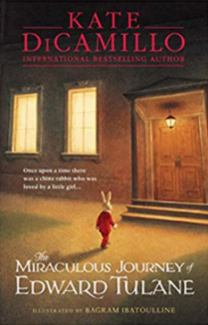  Miraculous Journey of Edward Tullane | 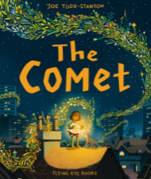  The Comet | Moon Juice  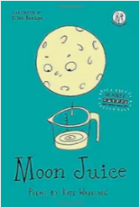 | Cinderella of the Nile  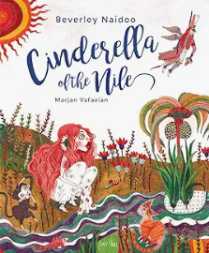 | Rhythm of the Rain  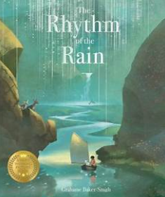  Water | Charging About: The Story of  Electricity  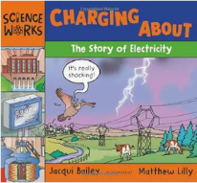  Greek Myths – Midas  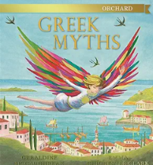
Author | Kate DiCamillo | Joe Todd-Stanton | Kate Wakeling | Beverly Naidoo | Grahame Baker-Smith | Jaqui Bailey
Theme | Empathy/Kindness | Growing and Changing | Growing and Changing | Resilience  Egyptians | Water/Rivers | Ancient Greece
Literary form | Narrative | Narrative | Narrative  Poetry | Narrative | Narrative | Non-fiction  Myth
Linked texts | My Beautiful Voice (pb)  In Our Hands  Shu Lin’s Grandpa  The Day You Begin  Wed Wabbit | Krindlekrax  I was a Rat  Grandpa Green  Changes  Saving the Butterfly | The Proudest Blue  Window  Belonging | Cinderella Liberator  The Egyptian Cinderella  My Nine Lives by Clio  Flat Stanley: The Great Egyptian Grave Robbery  Secrets of a Sun King  Marcy and the Riddle of the Sphinx | The River Story – Meredith Hooper  A River – Marc Martin  Flood (pb) – Alvaro Villa  The River (f)  Once Upon a Raindrop (nf/p)  Wind in the willows  The River – Hanako Clulow  Water Cycles - DK | Who Let the Gods Out  Mythologica – encyclopaedia  Greek Myths and Mazes  FArTHER  Ancient Greeks (nf)  Greek Myths (Marcia Williams) (nf)  Falling out of the Sky (p)
Reading objectives | Word Reading:  Pupils should be taught to:  - continue to apply phonic knowledge and skills as the route to decode words which are outside their spoken vocabulary  - use strategies such as recognising syllables /phonemes to decode most new words outside their spoken vocabulary (Y4 only)  - match what they decode to words they may have already heard but may not have seen in print [for example, in reading ‘technical’, the pronunciation /tɛtʃnɪkəl/ (‘tetchnical’) might not sound familiar, but /tɛknɪkəl/ (‘teknical’) should]  - re-read and refine reading of phrases or clauses that are tricky to read aloud smoothly on first attempt so that fluency is improved  - read most words accurately and at a speed that is sufficient for them to focus on understanding what they read rather than on decoding individual words  - test out different plausible pronunciations for less familiar words  - read further exception words, noting the unusual correspondences between spelling and sound, and where these occur in the word  - apply their growing knowledge of root words, prefixes and suffixes (etymology and morphology) as listed in English appendix 1, both to read aloud and to understand the meaning of new words they meet  - read longer words, using syllable boundaries (where needed Y4) and reading each syllable separately before they combine them to read the word  - [children should be able to read and understand words with contractions independently. If they are not able to do so, please refer to previous year groups.]  - read aloud unfamiliar words or challenging sections of text, where needed, to support accuracy and automaticity  - re-read words or challenging sections of text to ensure understanding through fluency  - read age-appropriate texts fluently (including pausing appropriately, reading in phrases, responding to punctuation)  Comprehension:  Pupils should be taught to:  - Develop positive attitudes to reading and understanding of what they read by (Y3 & Y4)  - Understand what they read, in books they can read independently, by (Y3 & Y4)  - Discuss how authors use language, including figurative language, considering the impact on the reader (Y3 & Y4)  - Retrieve and record information from non-fiction (Y3 & Y4)  - Distinguish between statements of fact and opinion (Y3 & Y4)  - Begin to provide reasoned justification for their views (Y4)  - Participate in discussion about both books that are read to them and those they can read for themselves, taking turns and listening to what others say (Y3 & Y4)  - Explain and discuss their understanding of books, poems and other material, both those that they listen to and those that they read for themselves (Y3 & Y4)
Cross curricular reference  (Geography, history, science) | Ancient Sumer  The Indus Valley  The Shang Dynasty of China Ancient | UK Cities  Animals including humans | Egypt  Animals including humans | UK Settlement and Land-use  States of Matter | Ancient Greece  Light | The Water Cycle  Rivers  Sound

Year: 3/4 B | Autumn 1 | Autumn 2 | Spring 1 | Spring 2 | Summer 1 | Summer 2
Book  (Main Driver Text) | 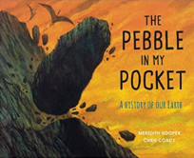  The Pebble in my Pocket  The Secrets of Stonehenge  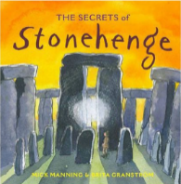 | The Steadfast Tin Soldier  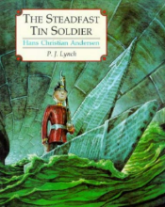  The Robot and the Bluebird  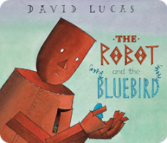 | Blue John  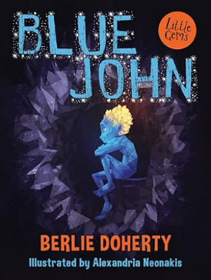 | The Tear Thief (f)  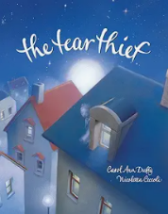  The Language of Cat (p)  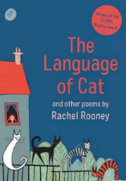 | Hermelin: The Detective Mouse  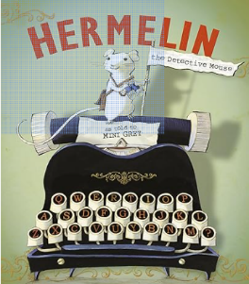 | Escape from Pompeii  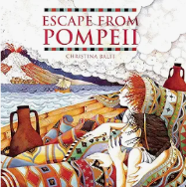  Earth Shattering Events  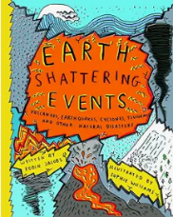
Author | Meredith Hooper  Mick Manning | Naomi Lewis | Berlie Doherty | Carol Ann Duffy  Rachel Rooney | Mini Grey | Christina Balit  Sophie Williams
Theme | Stone Age | Overcoming fear |  | Moral dilemmas  family | Challenging stereotypes | Extreme Earth
Literary form | Non-fiction | Narrative | Picture Book | Narrative | Narrative | Non-fiction
Linked texts | A Stone for Sascha  Stone Age Boy  Ugg: Boy Genius of Stone Age  Dave’s Cave  Dave’s Rock  The Secrets of Stonehenge (nf)  The Stone Age Tablet  Stone Age, Bone Age!  When We Became Humans  A Rock is Lively  The Street Beneath My Feet | The Robot and the Blue Bird  Iron Man – Ted Hughes  The Wild Robot  The Iron Man  The Miraculous Journey of Edward Tullane  Little Home Bird  Bluebird  Runaway Robot  Hands Christian Andersen – Stories and Fairytales | Snow Queen  Journey  Quest  The Dark  Flashlight  The Pebble in my Pocket | The Lost Happy Endings  The Colour Monster  The Heart and the Bottle – Oliver Jeffers  Burglar Bill  Cat Poems  T.S. Eliot – Old Possum’s book of Practical Cats | Mini Grey books:  Traction Man  The Last Wolf (ks1)  Biscuit Bear  Toys in Space  The Greatest Show on Earth  Hermelin  The Adventures of the Dish and the Spoon | The Firework Maker’s Daughter  Pebble in My Pocket  Roman Mysteries – The Secrets of Vesuvius  Roman Fort nf – Nick Manning  Empire’s End – A Roman Story (Leila Rasheed) diversity  Queen of Darkness  Real Life Disasters – Mega eruption  Earth Shattering Earthquakes – Horrible Geography
Reading objectives | Word Reading:  Pupils should be taught to:  - continue to apply phonic knowledge and skills as the route to decode words which are outside their spoken vocabulary  - use strategies such as recognising syllables /phonemes to decode most new words outside their spoken vocabulary (Y4 only)  - match what they decode to words they may have already heard but may not have seen in print [for example, in reading ‘technical’, the pronunciation /tɛtʃnɪkəl/ (‘tetchnical’) might not sound familiar, but /tɛknɪkəl/ (‘teknical’) should]  - re-read and refine reading of phrases or clauses that are tricky to read aloud smoothly on first attempt so that fluency is improved  - read most words accurately and at a speed that is sufficient for them to focus on understanding what they read rather than on decoding individual words  - test out different plausible pronunciations for less familiar words  - read further exception words, noting the unusual correspondences between spelling and sound, and where these occur in the word  - apply their growing knowledge of root words, prefixes and suffixes (etymology and morphology) as listed in English appendix 1, both to read aloud and to understand the meaning of new words they meet  - read longer words, using syllable boundaries (where needed Y4) and reading each syllable separately before they combine them to read the word  - [children should be able to read and understand words with contractions independently. If they are not able to do so, please refer to previous year groups.]  - read aloud unfamiliar words or challenging sections of text, where needed, to support accuracy and automaticity  - re-read words or challenging sections of text to ensure understanding through fluency  - read age-appropriate texts fluently (including pausing appropriately, reading in phrases, responding to punctuation)  Comprehension:  Pupils should be taught to:  - Develop positive attitudes to reading and understanding of what they read by (Y3 & Y4)  - Understand what they read, in books they can read independently, by (Y3 & Y4)  - Discuss how authors use language, including figurative language, considering the impact on the reader (Y3 & Y4)  - Retrieve and record information from non-fiction (Y3 & Y4)  - Distinguish between statements of fact and opinion (Y3 & Y4)  - Begin to provide reasoned justification for their views (Y4)  - Participate in discussion about both books that are read to them and those they can read for themselves, taking turns and listening to what others say (Y3 & Y4)  Explain and discuss their understanding of books, poems and other material, both those that they listen to and those that they read for themselves (Y3 & Y4)
Cross curricular reference | Stone Age  Rocks and Soils | Europe | Iron Age  Forces and Magnets | Europe and Local Study  Electricity | Roman Empire  Plants | Volcanoes  Living things and their Habitats

