Year: 1/2 A |  | Autumn 1 | Autumn 2 | Spring 1 | Spring 2 | Summer 1 | Summer 2
Core texts |  | The Last Wolf  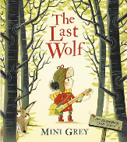  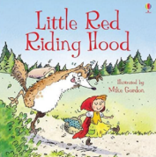  Little Red Riding Hood | Bog Baby  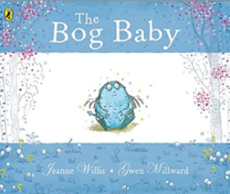 | Pumpkin Soup  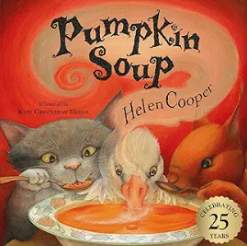 | 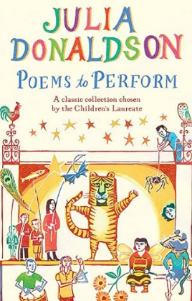  Poems to Perform (clpe) | Look What I Found in the Woods  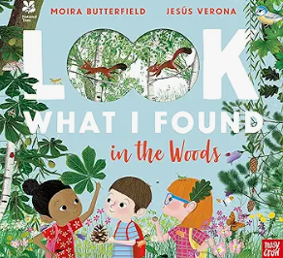 | Leaf  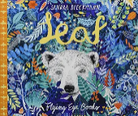  Grandma Bird  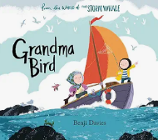
Author |  | Mini Grey | Jeanne Willis | Helen Cooper | Julia Donaldson | Moira Butterfield | Sandra Dieckmann  Benji Davis
Theme |  | Fairytales  Imaginary worlds  Empathy and Kindness | Magical creatures  Empathy and Kindness | Friendship | Rhyme, repetition and onomatopoeia | The woods | Belonging and Friendship
Literary form |  | Narrative  Classic fairy tale | Narrative  Magical text | Narrative  Traditional tale | Poetry  Performance Poetry | Non-fiction | Narrative  Contemporary fiction
Linked texts |  | Little Red  Red and the City  The Wolf’s Story  Mini Grey: Three By the Sea; Traction Man; Hermelin  The Lost Words  The Day the Crayons Quit | The King of the Tiny Things  The Lonely Beast  Beegu  The Lorax | On Sudden Hill  The Snail and the Whale  The Squirrels who Squabbled  Percy the Park Keeper stories  Helen Cooper A Pipkin of Pepper and Delicious  Mine! Rachel Bright  Pattan’s Pumpkin  Bear Snores On – Karma Wilson | The Puffin Book of Fantastic First Poems  The Dragon with a Big Nose’ - Kathy Henderson  ‘All the Best. The Selected Poems’ by Roger McGough Caribbean Playground Song read by James Berry (clpe)  Dog in the Playground read by Allan Ahlberg from his ‘Collected Poems (clpe)  Everybody’s Got a Gift by Grace Nichols | The Lost Words  The Secret Life of Trees  A seed is Sleepy  It Starts With a Seed  Look what I found at the Seaside  The Things that I LOVE about trees | Leaf Man  Beegu  Tree: Seasons Come and Go  The Storm Whale  The Storm Whale in Winter  Where the Wild Things Are  Gregory Cool  Billy’s Bucket  Sally and the Limpet
Reading objectives | Year 1  Word reading:  Pupils should be taught to:  - apply phonic knowledge and skills as the route to decode words accurately  - read left-to-right through words, attending to known GPCs in order  - respond speedily with the correct sound to graphemes (letters or groups of letters) for all 40+ phonemes, including, where applicable, alternative sounds for graphemes  - read words containing previously taught GPCs (grapheme/ phoneme correspondence) without overt sounding and blending after a few encounters  - read accurately by blending sounds within unfamiliar words containing GPCs (grapheme/ phoneme correspondence) that have been taught  - read common exception words [according to school’s chosen phonics programme], noting unusual correspondences between spelling and sound and where these occur in the word  - read words containing taught GPCs (grapheme/phoneme correspondence) and –s, -es, - ing, -ed, -er and –est endings  - read words with suffixes by being helped to build on the root words that they can read already  - read other words of more than one syllable that contain taught GPCs  - read words with contractions [for example, I’m, I’ll, we’ll], and understand that the apostrophe represents the omitted letter(s)  - read aloud accurately books that are consistent with their developing phonic knowledge and that do not require them to use other strategies to work out words  - re-read these books to build up their fluency and confidence in word reading  - read age-appropriate texts fluently (including pausing appropriately, reading in phrases, responding to punctuation)  Comprehension:  Pupils should be taught to:  Develop pleasure in reading, motivation to read, vocabulary and understanding by:  • listening to and discussing a wide range of poems, stories and non-fiction at a level beyond that at which they can read independently  • sharing and discussing non-fiction books and how they can be used to find things out  • identifying with, and exploring characters through role play  • being encouraged to link what they read or hear with their own experiences  • becoming very familiar with key stories, fairy stories and traditional tales, retelling them and considering their particular characteristics  • discussing the sequence of events in texts  • recognising elements that have been encountered in other texts e.g talking animals, grandparents, cottage in the woods, family home, magical objects, friends/friendship  • discussing word meanings, linking new meanings to those already known  • sustaining engagement with a book  • recognising and joining in with predictable phrases e.g. How goes the work?; Run, run as fast as you can. You can’t catch me, I’m the Gingerbread Man!’  • reciting some rhymes and poems learnt by heart  • learning to appreciate rhymes and poems  Understand both the books they can already read accurately and fluently and those they listen to by:  • drawing on what they already know or on background information and vocabulary provided by the teacher  • checking that the text makes sense to them as they read and correcting inaccurate reading  • reading with some appropriate expression  • responding to open questions and prompts e.g. tell me about…  • asking questions to improve their understanding of a text, including through individual inner dialogue while reading and discussion after/during reading e.g. What if a tiger came to my house? Why did the tiger drink all of the milk?  • using tentative language to speculate on possibilities raised by the text e.g. Maybe he likes farms. That is why he is called Farmer Duck. I think Farmer Duck must be very tired  • making connections with what they read or hear to own experiences e.g. ‘I like going to the beach too’  • making inferences on the basis of what is being said and done  • recognising different thoughts/feelings of main characters within a text  • recognise different settings within a text  • predicting what might happen on the basis of what has been read so far  • making predictions about how a character might behave  • discussing settings and what they indicate about the story  • recalling main events/ideas from a text  • re-reading to find specific information  Discuss how authors use language including literary language by:  • discussing language choices that are key to the text  • recognising typical phrases found in stories  Provide reasons for their views by:  • justifying (with support), their views about texts they have had read to them and others that they read for themselves e.g. ‘Puffin Peter looked and looked everywhere for Paul because he really missed him.’  • sharing personal preferences regarding named books  Participate in a discussion about what is read to them, taking turns and listening to what others say by:  • listening attentively in discussion and beginning to make related comments  • taking some account of other speakers’ comments, e.g. in paired work  • asking questions to find out specific information including ‘How’ and ‘Why’  • participating in discussions  • following agreed group discussion guidelines  • taking turns  • sometimes expressing a view/opinion  Explain clearly their understanding of what is read to them by:  • sharing their own views about what has been read to them  • explaining their view using the word ‘because’  Year 2  Word Reading:  Pupils should be taught to:  continue to apply phonic knowledge and skills as the route to decode words until automatic decoding has become embedded and reading is fluent  • read all the words in a sentence and do this accurately, so that their understanding of what they read is not hindered by imprecise decoding (for example, by reading ‘place’ instead of ‘palace’)  • re-read word groups that are tricky to read aloud smoothly on first attempt  • read most words quickly and accurately, without overt sounding and blending, when they have been frequently encountered  • read unfamiliar words containing previously taught GPCs (grapheme/phoneme correspondence), accurately and without undue hesitation  • read accurately by blending the sounds in unfamiliar words that contain the graphemes taught so far, especially recognising alternative sounds for graphemes  • read further common exception words [according to school’s chosen phonics programme], noting unusual correspondences between spelling and sound and where these occur in the word  • read words containing common suffixes  • read suffixes by building on the root words that they have already learnt  • read accurately words of two or more syllables that contain the graphemes taught so far  • use syllable boundaries to read each syllable separately before they combine them to read longer words  • use morphology (such as prefixes) to work out unknown words  • read further words with contractions [for example, couldn’t, wouldn’t, shouldn’t, can’t], and understand that the apostrophe represents the omitted letter(s)  • read aloud books closely matched to their improving phonic knowledge, sounding out unfamiliar words accurately, automatically and without undue hesitation  • re-read these books to build up their fluency and confidence in word reading  • read age-appropriate texts fluently (including pausing appropriately, reading in phrases, responding to punctuation)  Comprehension:  Pupils should be taught to:  Develop pleasure in reading, motivation to read, vocabulary and understanding by:  • listening to, discussing and expressing views about a wide range of contemporary and classic poetry, stories and non-fiction at a level beyond that at which they can read independently  • exploring non-fiction books that are structured in different ways, and how they can be used to find things out  • empathising with characters, based on their descriptions and actions  • identifying with, and exploring characters, using a range of drama techniques e.g. through role play, improvisation, using voice, gesture or movement, hot seating, freeze framing; role on the wall; conscience alley  • linking what they read or hear with their own experiences  • becoming increasingly familiar with and retelling a wider range of stories, fairy stories and traditional tales  • discussing the sequence of events in texts and how items of information are related  • identifying elements that have been encountered in other texts e.g talking animals, grandparents, cottage in the woods, family home, magical objects, friends/friendship  • discussing and clarifying the meanings of words, linking new meanings to known vocabulary  • discussing their favourite words and phrases  • sustaining interest in longer narratives  • recognising simple recurring literary language in stories and poetry e.g. All the better to see/hear/eat you with; Once upon a time ...  • building a repertoire of poems learnt by heart  • appreciating poems, reciting some, with appropriate intonation to make the meaning clear  Understand both the books they can already read accurately and fluently and those they listen to by:  • drawing on what they already know or on background information and vocabulary provided by the teacher  • checking that the text makes sense to them as they read and correcting inaccurate reading  • reading with appropriate expression and phrasing  • responding to open questions and prompts e.g. tell me about…  • asking questions to improve their understanding of a text, including through individual inner dialogue while reading and discussion after/during reading e.g. Would I give away all of my nice clothes if I’d only just got them? Who was helped most by the giant?  • using tentative language to speculate on possibilities raised by the text e.g Rapunzel probably feels worried about what the witch will do to her. Maybe she should say she is sorry but then she can sneak out again.  • making connections with what they read or hear to own experiences e.g. Sometimes you have to do things you don’t want to, to help somebody else – like when the Winter’s Child goes home. Like when me and my sister had to be quiet because my dad was ill.  • making inferences on the basis of what is being said and done  • recognising different thoughts/feelings from characters within a text  • beginning to recognise that settings may affect feelings and behaviours  • predicting what might happen on the basis of what has been read so far  • making predictions about how a character might behave  • discussing settings and what they indicate about the story  • recalling main events/ideas from a text  • conveying simple information derived from main ideas  • re-reading to find specific information  • retrieves information from within a text  • understanding that language structure and presentation contribute to meaning (see Assessing with Age-Related Texts for fiction examples) for language: o ‘This is known as migration,’; ‘Until recently many birds would fly to Africa for the winter.’ for structure: o distinct sections of information, e.g. grouped onto a double page spread; sub-headings for presentation: o picture book covers and endpapers often provide clues about a story; bold and/or enlarged texts for more emphatic speech; speech bubbles and thought clouds o Illustrations are bright and engaging and illustrate concepts and processes.  Discuss how authors use language including literary language by:  • discussing effective language choices  • Identifying and discussing simple figurative words and phrases  • exploring synonyms and idiomatic language (often seemingly simple words working together for a particular meaning) e.g. ‘sharp ears’ Tear Thief  Provide reasons for their views by:  • beginning to independently justify their views about texts they have had read to them and others that they read for themselves, beginning to refer back to the text for evidence e.g. ‘I think Tom really loves Nana because he chopped up his skis for firewood.’  • sharing personal preferences regarding authors and named books  Participate in discussion about books, poems and other works that are read to them and those that they can read for themselves, taking turns and listening to what others say by:  • listening attentively in discussion and making related comments  • considers alternative viewpoints  • asking questions for clarification and understanding  • participating in discussions  • speaking audibly to a group  • following agreed group discussion guidelines  • taking turns in group or class conversations  • sharing a view/opinion  • considering the opinions of others (with support)  Explain and discuss their understanding of books, poems and other material, both those that they listen to and those that they read for themselves by:  • talking about what they are reading and what has been read to them  • sharing personal responses  • explaining their view using words such as ‘because’ and using evidence from the context  • explaining to others what they have read or found out
Cross curricular reference  (Geography, history, science) |  | Local Study – Sandbach  History of our school  Seasonal Change | Gunpowder Plot  Animals Including humans  Seasonal Change | Great Fire of London  Plants  Seasonal Change | The UK  Seasonal Change | Explorers  Plants  Seasonal Change | Hot and Cold  Seasonal Change

Year: 1/2 B | Autumn 1 | Autumn 2 | Spring 1 | Spring 2 | Summer 1 | Summer 2
Book  (Main Driver Text) | The Way Home for Wolf  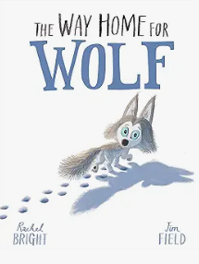 | Winter Sleep  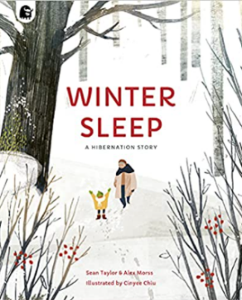 | The Wolf, The Duck and the Mouse  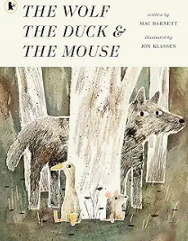 | Once Upon a Raindrop  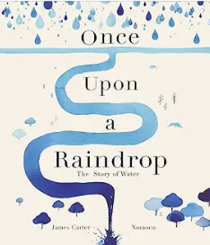 | Look Up  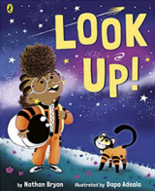  Message from the Moon  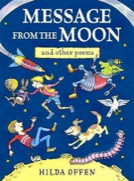 | The Song of the Nightingale  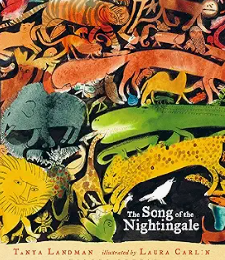
Author | Rachel Bright and Jim Field | Sean Taylor | Mac Barnett and Jon Klassen | James Carter | Nathan Bryon and Dapo Adeola  Hilda Offen | Tanya Landman
Theme | Friendship, kindness, self-belief | Winter | Fear and courage | Water | Space | Oceans
Literary form | Fiction  Picturebook | Non-fiction | Fiction  Picturebook | Non-fiction | Narrative  Poetry | Picturebook
Linked texts  Picture books, poetry, Bob Cox extracts etc. | Ice Bear – Nicola Davies  The Squirrels who Squabbled  The Koala who could  The Lion Inside  First Animal Encyclopaedia  One Day on our Blue Planet | Snow by Walter de la Mare (p)  The Snowman  A thing called Snow (pb)  Secrets of Winter (nf)  Robin’s Winter Song  The First Book of Nature  Yucky Worms! | This is not my hat  I want my hat back  Square, triangle circle  Good little Wolf  The Bear and the Piano  Jeremiah in the Dark Woods  Journey  Maps | The Rhythm of the Rain  Once upon a star. The Story of our Sun  Here we Are  The Water Princess | Bob, Man on the Moon  Bob’s Best Ever Friend  Laika:Astronaut Dog (pb)  Field Trip to the Moon (pb)  The Darkest Dark  Toys in Space  Women in Science  Black and British  Books about families | The Glassmaker’s Daughter  An Anthology of Aesop's Fables  Just So Stories  Wings Waves and Webs  I can see Nature’s Rainbow  One World, Many Colours
Reading objectives | Year 1  Word reading:  Pupils should be taught to:  - apply phonic knowledge and skills as the route to decode words accurately  - read left-to-right through words, attending to known GPCs in order  - respond speedily with the correct sound to graphemes (letters or groups of letters) for all 40+ phonemes, including, where applicable, alternative sounds for graphemes  - read words containing previously taught GPCs (grapheme/ phoneme correspondence) without overt sounding and blending after a few encounters  - read accurately by blending sounds within unfamiliar words containing GPCs (grapheme/ phoneme correspondence) that have been taught  - read common exception words [according to school’s chosen phonics programme], noting unusual correspondences between spelling and sound and where these occur in the word  - read words containing taught GPCs (grapheme/phoneme correspondence) and –s, -es, - ing, -ed, -er and –est endings  - read words with suffixes by being helped to build on the root words that they can read already  - read other words of more than one syllable that contain taught GPCs  - read words with contractions [for example, I’m, I’ll, we’ll], and understand that the apostrophe represents the omitted letter(s)  - read aloud accurately books that are consistent with their developing phonic knowledge and that do not require them to use other strategies to work out words  - re-read these books to build up their fluency and confidence in word reading  - read age-appropriate texts fluently (including pausing appropriately, reading in phrases, responding to punctuation)  Comprehension:  Pupils should be taught to:  Develop pleasure in reading, motivation to read, vocabulary and understanding by:  • listening to and discussing a wide range of poems, stories and non-fiction at a level beyond that at which they can read independently  • sharing and discussing non-fiction books and how they can be used to find things out  • identifying with, and exploring characters through role play  • being encouraged to link what they read or hear with their own experiences  • becoming very familiar with key stories, fairy stories and traditional tales, retelling them and considering their particular characteristics  • discussing the sequence of events in texts  • recognising elements that have been encountered in other texts e.g talking animals, grandparents, cottage in the woods, family home, magical objects, friends/friendship  • discussing word meanings, linking new meanings to those already known  • sustaining engagement with a book  • recognising and joining in with predictable phrases e.g. How goes the work?; Run, run as fast as you can. You can’t catch me, I’m the Gingerbread Man!’  • reciting some rhymes and poems learnt by heart  • learning to appreciate rhymes and poems  Understand both the books they can already read accurately and fluently and those they listen to by:  • drawing on what they already know or on background information and vocabulary provided by the teacher  • checking that the text makes sense to them as they read and correcting inaccurate reading  • reading with some appropriate expression  • responding to open questions and prompts e.g. tell me about…  • asking questions to improve their understanding of a text, including through individual inner dialogue while reading and discussion after/during reading e.g. What if a tiger came to my house? Why did the tiger drink all of the milk?  • using tentative language to speculate on possibilities raised by the text e.g. Maybe he likes farms. That is why he is called Farmer Duck. I think Farmer Duck must be very tired  • making connections with what they read or hear to own experiences e.g. ‘I like going to the beach too’  • making inferences on the basis of what is being said and done  • recognising different thoughts/feelings of main characters within a text  • recognise different settings within a text  • predicting what might happen on the basis of what has been read so far  • making predictions about how a character might behave  • discussing settings and what they indicate about the story  • recalling main events/ideas from a text  • re-reading to find specific information  Discuss how authors use language including literary language by:  • discussing language choices that are key to the text  • recognising typical phrases found in stories  Provide reasons for their views by:  • justifying (with support), their views about texts they have had read to them and others that they read for themselves e.g. ‘Puffin Peter looked and looked everywhere for Paul because he really missed him.’  • sharing personal preferences regarding named books  Participate in a discussion about what is read to them, taking turns and listening to what others say by:  • listening attentively in discussion and beginning to make related comments  • taking some account of other speakers’ comments, e.g. in paired work  • asking questions to find out specific information including ‘How’ and ‘Why’  • participating in discussions  • following agreed group discussion guidelines  • taking turns  • sometimes expressing a view/opinion  Explain clearly their understanding of what is read to them by:  • sharing their own views about what has been read to them  • explaining their view using the word ‘because’  Year 2  Word Reading:  Pupils should be taught to:  continue to apply phonic knowledge and skills as the route to decode words until automatic decoding has become embedded and reading is fluent  • read all the words in a sentence and do this accurately, so that their understanding of what they read is not hindered by imprecise decoding (for example, by reading ‘place’ instead of ‘palace’)  • re-read word groups that are tricky to read aloud smoothly on first attempt  • read most words quickly and accurately, without overt sounding and blending, when they have been frequently encountered  • read unfamiliar words containing previously taught GPCs (grapheme/phoneme correspondence), accurately and without undue hesitation  • read accurately by blending the sounds in unfamiliar words that contain the graphemes taught so far, especially recognising alternative sounds for graphemes  • read further common exception words [according to school’s chosen phonics programme], noting unusual correspondences between spelling and sound and where these occur in the word  • read words containing common suffixes  • read suffixes by building on the root words that they have already learnt  • read accurately words of two or more syllables that contain the graphemes taught so far  • use syllable boundaries to read each syllable separately before they combine them to read longer words  • use morphology (such as prefixes) to work out unknown words  • read further words with contractions [for example, couldn’t, wouldn’t, shouldn’t, can’t], and understand that the apostrophe represents the omitted letter(s)  • read aloud books closely matched to their improving phonic knowledge, sounding out unfamiliar words accurately, automatically and without undue hesitation  • re-read these books to build up their fluency and confidence in word reading  • read age-appropriate texts fluently (including pausing appropriately, reading in phrases, responding to punctuation)  Comprehension:  Pupils should be taught to:  Develop pleasure in reading, motivation to read, vocabulary and understanding by:  • listening to, discussing and expressing views about a wide range of contemporary and classic poetry, stories and non-fiction at a level beyond that at which they can read independently  • exploring non-fiction books that are structured in different ways, and how they can be used to find things out  • empathising with characters, based on their descriptions and actions  • identifying with, and exploring characters, using a range of drama techniques e.g. through role play, improvisation, using voice, gesture or movement, hot seating, freeze framing; role on the wall; conscience alley  • linking what they read or hear with their own experiences  • becoming increasingly familiar with and retelling a wider range of stories, fairy stories and traditional tales  • discussing the sequence of events in texts and how items of information are related  • identifying elements that have been encountered in other texts e.g talking animals, grandparents, cottage in the woods, family home, magical objects, friends/friendship  • discussing and clarifying the meanings of words, linking new meanings to known vocabulary  • discussing their favourite words and phrases  • sustaining interest in longer narratives  • recognising simple recurring literary language in stories and poetry e.g. All the better to see/hear/eat you with; Once upon a time ...  • building a repertoire of poems learnt by heart  • appreciating poems, reciting some, with appropriate intonation to make the meaning clear  Understand both the books they can already read accurately and fluently and those they listen to by:  • drawing on what they already know or on background information and vocabulary provided by the teacher  • checking that the text makes sense to them as they read and correcting inaccurate reading  • reading with appropriate expression and phrasing  • responding to open questions and prompts e.g. tell me about…  • asking questions to improve their understanding of a text, including through individual inner dialogue while reading and discussion after/during reading e.g. Would I give away all of my nice clothes if I’d only just got them? Who was helped most by the giant?  • using tentative language to speculate on possibilities raised by the text e.g Rapunzel probably feels worried about what the witch will do to her. Maybe she should say she is sorry but then she can sneak out again.  • making connections with what they read or hear to own experiences e.g. Sometimes you have to do things you don’t want to, to help somebody else – like when the Winter’s Child goes home. Like when me and my sister had to be quiet because my dad was ill.  • making inferences on the basis of what is being said and done  • recognising different thoughts/feelings from characters within a text  • beginning to recognise that settings may affect feelings and behaviours  • predicting what might happen on the basis of what has been read so far  • making predictions about how a character might behave  • discussing settings and what they indicate about the story  • recalling main events/ideas from a text  • conveying simple information derived from main ideas  • re-reading to find specific information  • retrieves information from within a text  • understanding that language structure and presentation contribute to meaning (see Assessing with Age-Related Texts for fiction examples) for language: o ‘This is known as migration,’; ‘Until recently many birds would fly to Africa for the winter.’ for structure: o distinct sections of information, e.g. grouped onto a double page spread; sub-headings for presentation: o picture book covers and endpapers often provide clues about a story; bold and/or enlarged texts for more emphatic speech; speech bubbles and thought clouds o Illustrations are bright and engaging and illustrate concepts and processes.  Discuss how authors use language including literary language by:  • discussing effective language choices  • Identifying and discussing simple figurative words and phrases  • exploring synonyms and idiomatic language (often seemingly simple words working together for a particular meaning) e.g. ‘sharp ears’ Tear Thief  Provide reasons for their views by:  • beginning to independently justify their views about texts they have had read to them and others that they read for themselves, beginning to refer back to the text for evidence e.g. ‘I think Tom really loves Nana because he chopped up his skis for firewood.’  • sharing personal preferences regarding authors and named books  Participate in discussion about books, poems and other works that are read to them and those that they can read for themselves, taking turns and listening to what others say by:  • listening attentively in discussion and making related comments  • considers alternative viewpoints  • asking questions for clarification and understanding  • participating in discussions  • speaking audibly to a group  • following agreed group discussion guidelines  • taking turns in group or class conversations  • sharing a view/opinion  • considering the opinions of others (with support)  Explain and discuss their understanding of books, poems and other material, both those that they listen to and those that they read for themselves by:  • talking about what they are reading and what has been read to them  • sharing personal responses  • explaining their view using words such as ‘because’ and using evidence from the context  • explaining to others what they have read or found out
Cross curricular reference  (Geography, history, science) | History of Sandbach  Our School  Every day materials  Seasonal change | Remembrance Day  Seasonal change | The UK  Use of Every day materials  Seasonal change | The Railways  Seasonal change | Florence Nightingale  Living things and their habitats  Seasonal change | The seven continents and five oceans  Seasonal Change

