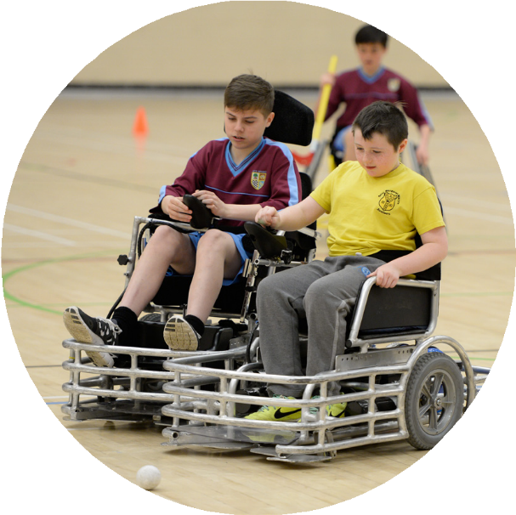
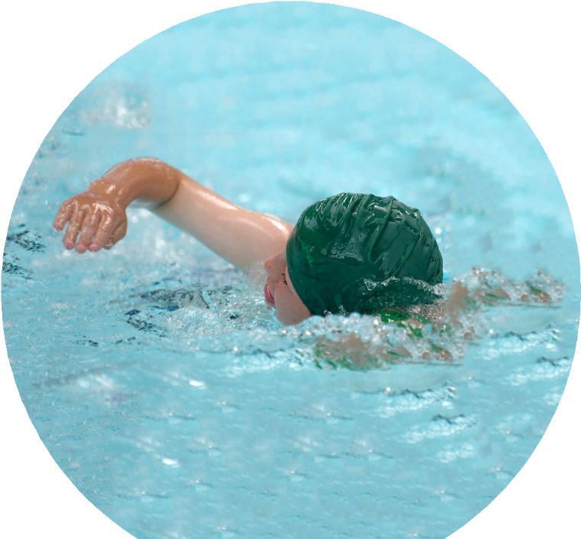
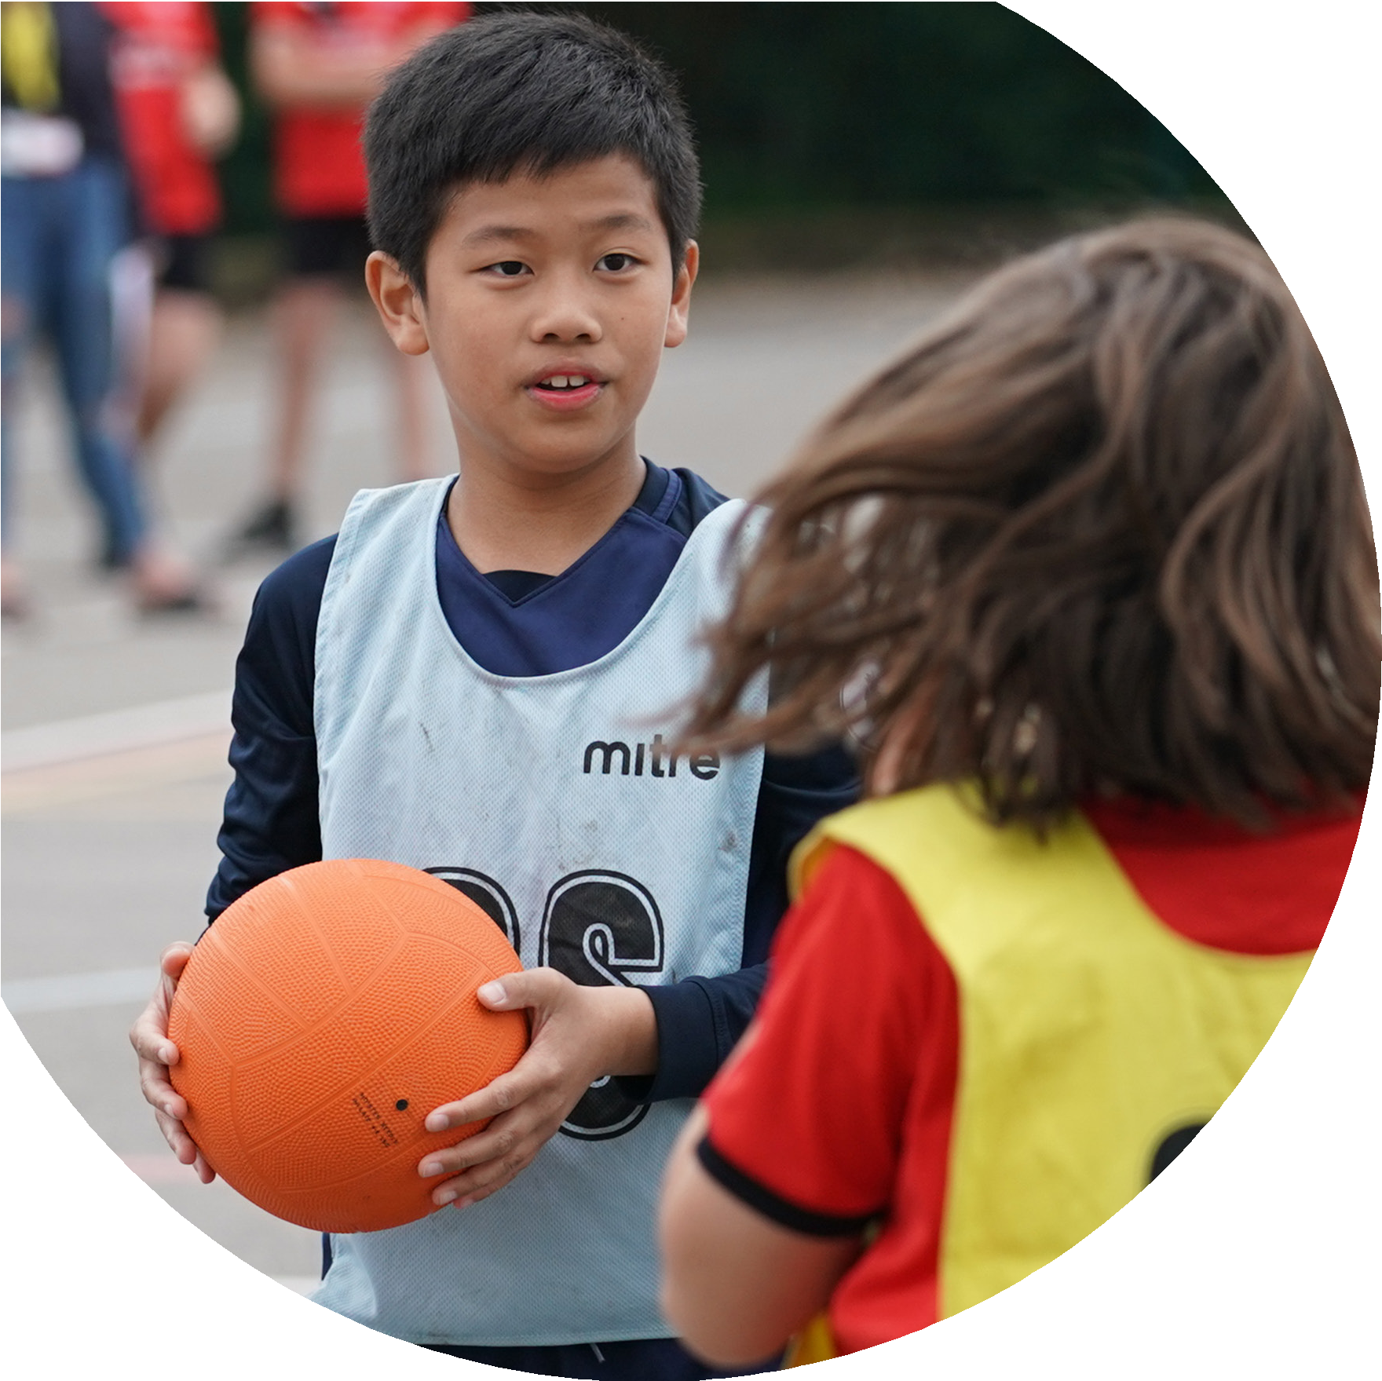

Evidencing the Impact of the Primary PE and Sport Premium
Website Reporting Tool Revised July 2022

Commissioned by

Created by

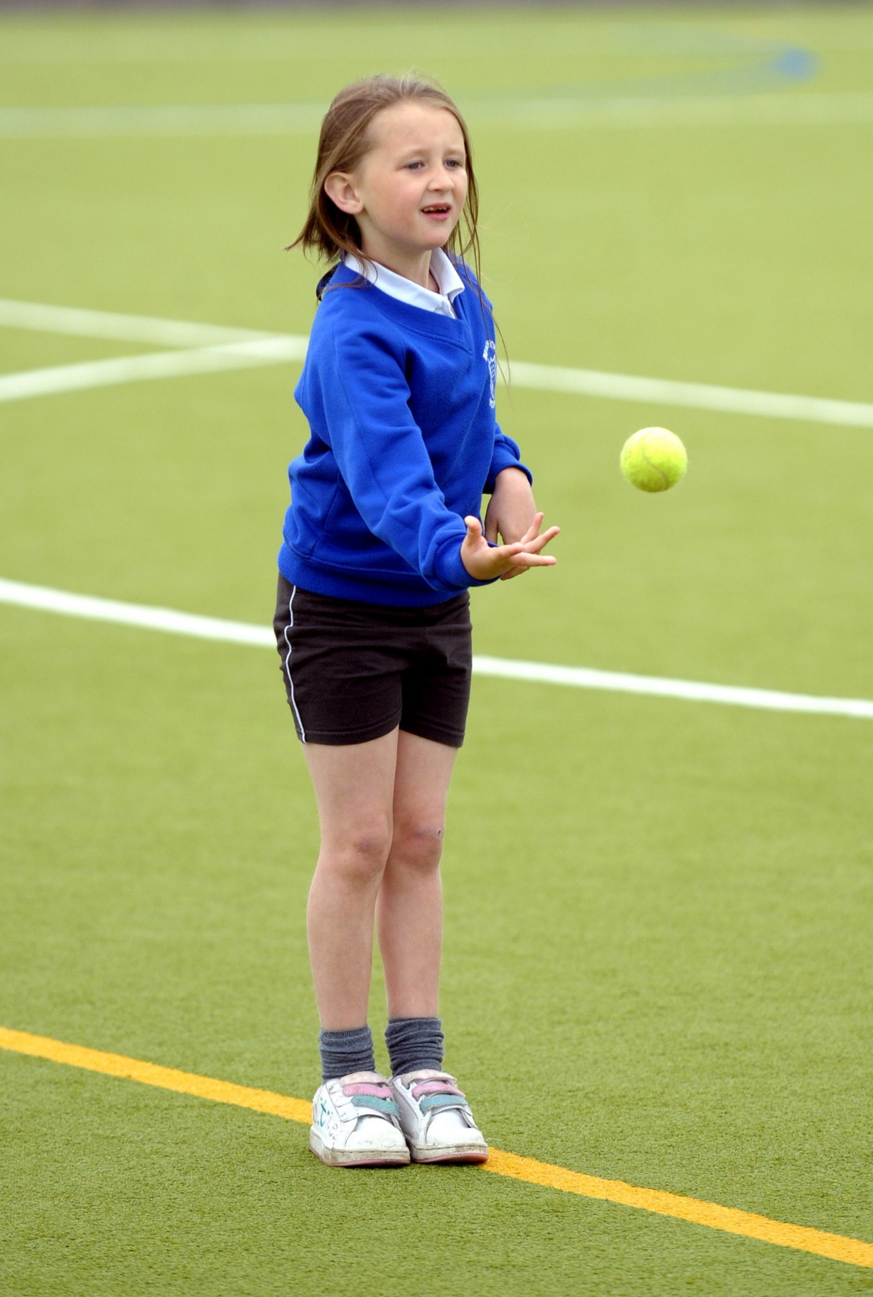
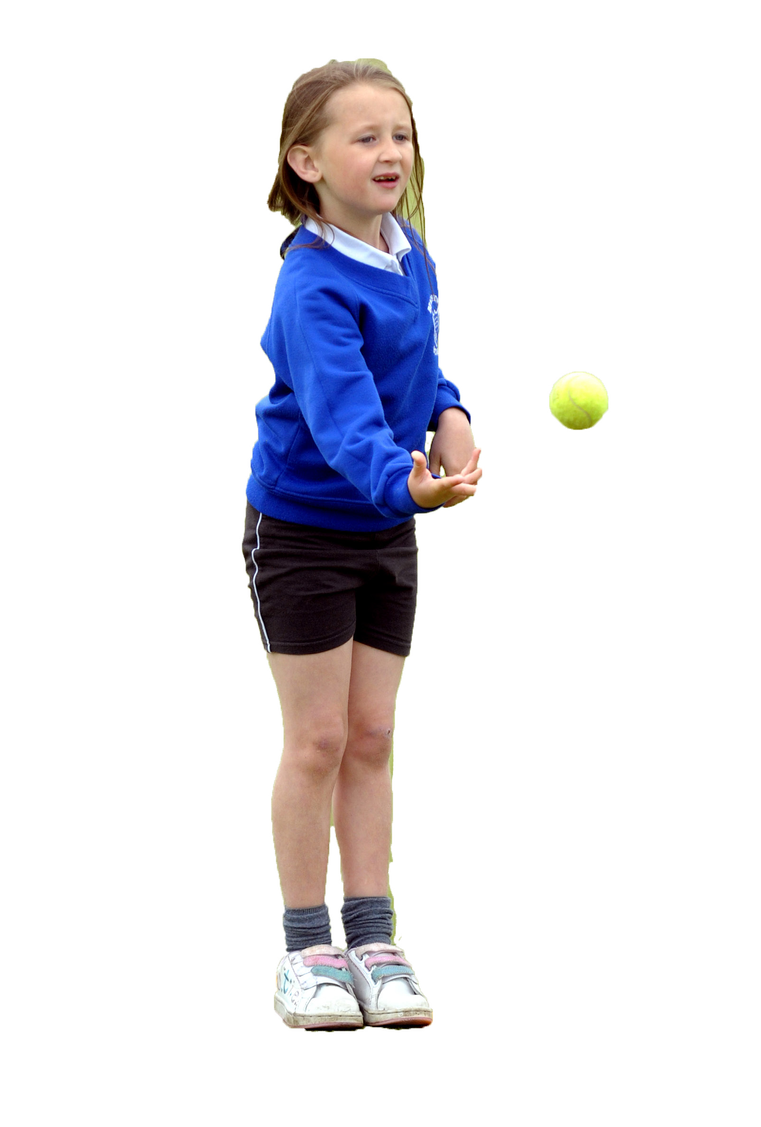

It is important that your grant is used effectively and based on school need. The Education Inspection Framework makes clear there will be a focus on ‘whether leaders and those responsible for governors all understand their respective roles and perform these in a way that enhances the effectiveness of the school’.

Under the Quality of Education Ofsted inspectors consider:
Intent - Curriculum design, coverage and appropriateness
Implementation - Curriculum delivery, Teaching (pedagogy) and Assessment
Impact - Attainment and progress

To assist schools with common transferable language this template has been developed to utilise the same three headings which should make your plans easily transferable between working documents.

Schools must use the funding to make additional and sustainable improvements to the quality of Physical Education, School Sport and Physical Activity (PESSPA) they offer. This means that you should use the Primary PE and sport premium to:

- Develop or add to the PESSPA activities that your school already offer
- Build capacity and capability within the school to ensure that improvements made now will benefit pupils joining the school in future years
- The Primary PE and sport premium should not be used to fund capital spend projects; the school’s budget should fund these.

Pleasevisitgov.ukfortherevisedDfEguidanceincludingthe5keyindicatorsacrosswhichschoolsshoulddemonstrate animprovement.Thisdocumentwillhelpyoutoreviewyourprovisionandtoreportyourspend.DfEencouragesschools to use this template as an effective way of meeting the reporting requirements of the Primary PE and Sport Premium.

We recommend you start by reflecting on the impact of current provision and reviewing the previous spend.

Schools are required to publish details of how they spend this funding, including any under-spend from 2021/2022, as well as on the impact it has on pupils’ PE and sport participation and attainment. All funding must be spent by 31st July 2023.

We recommend regularly updating the table and publishing it on your website throughout the year. This evidences your ongoing self-evaluation of how you are using the funding to secure maximum, sustainable impact. Final copy must be posted on your website by the end of the academic year and no later than the 31st July 2023. To see an example of how to complete the table please click HERE.
Created by: Supported by:

Details with regard to funding
Please complete the table below.

Total amount carried over from 2021/22 | £1,517.44
Total amount allocated for 2021/22 | £16,850
How much (if any) do you intend to carry over from this total fund into 2022/23? | £0
Total amount allocated for 2022/23 | £16,850
Total amount of funding for 2023/23. To be spent and reported on by 31st July 2023. | £16,850
Swimming Data
Please report on your Swimming Data below.

Meeting national curriculum requirements for swimming and water safety.  N.B. Complete this section to your best ability. For example you might have practised safe self-rescue techniques on dry land which you can then transfer to the pool when school swimming restarts.  Due to exceptional circumstances priority should be given to ensuring that pupils can perform safe self rescue even if they do not fully meet the first two requirements of the NC programme of study | All children engaged in safe self-rescue techniques during their course of swimming lessons.  We had 16 children in year 6 with 1 not swimming
What percentage of your current Year 6 cohort swim competently, confidently and proficiently over a distance of at least 25 metres?  N.B. Even though your pupils may swim in another year please report on their attainment on leaving primary school at the end of the summer term 2022.  Please see note above | 56.3%
What percentage of your current Year 6 cohort use a range of strokes effectively [for example, front crawl, backstroke and breaststroke]?  Please see note above | 56%
What percentage of your current Year 6 cohort perform safe self-rescue in different water-based situations? | 93.75%
Schools can choose to use the Primary PE and sport premium to provide additional provision for swimming but this must be for activity over and above the national curriculum requirements. Have you used it in this way? | No

Action Plan and Budget Tracking
Capture your intended annual spend against the 5 key indicators. Clarify the success criteria and evidence of impact that you intend to measure to evaluate for pupils today and for the future.

Academic Year: 2022/23 | Total fund allocated: | Date Updated:
Key indicator 1: The engagement of all pupils in regular physical activity – Chief Medical Officers guidelines recommend that primary school pupils undertake at least 30 minutes of physical activity a day in school |  |  |  | Percentage of total allocation:
 |  |  |  | %
Intent | Implementation |  | Impact
Your school focus should be clear what you want the pupils to know and be able to do and about  what they need to learn and to  consolidate through practice: | Make sure your actions to achieve are linked to your intentions: | Funding allocated: | Evidence of impact: what do pupils now know and what can they now do? What has changed?: | Sustainability and suggested next steps:
All staff feel confident in delivering PE, especially in their weaker areas and for non-specialists  Children will engage in 2 hours of PE lessons per week. One led by the class teacher and one led by sports coaches to include the engagement of all pupils.  More after school clubs to be available for the children in all year groups.  Lunch time clubs to be ran everyday to increase number of children engaging in physical activity at break times. | Arrange additional sessions with North West Coaching to support additional coaching/teaching opportunities for all staff.  Audit areas of need for staff – plan, monitor and evaluate sessions.  School to offer different lunchtime and after school sports clubs based on curriculum need and children’s own interests. | £11,310 | All pupils have access to 2 PE sessions per week. These lessons have involved a range of sports and skills from ball skills, athletics, Tennis, Cricket, Dance, Netball and football. Enabling our children to be confident in a full range of sporting activities.  Daily lunchtime clubs in place with a greater number of children engaging within them leading to more active break times. 2 PE based after school clubs running per week offered to children in KS1 and 2. | Continue with this into the 2023/2024 academic year.  Increase number of staff being involved in PE lessons and active break times to ensure sustainability in the long term.
Key indicator 2: The profile of PESSPA being raised across the school as a tool for whole school improvement |  |  |  | Percentage of total allocation:
 |  |  |  | %
Intent | Implementation |  | Impact | 10%
Your school focus should be clear what you want the pupils to know and be able to do and about  what they need to learn and to  consolidate through practice: | Make sure your actions to achieve are linked to your intentions: | Funding allocated: | Evidence of impact: what do pupils now know and what can they now do? What has changed?: | Sustainability and suggested next steps:
Children to have a greater understanding of how important their health is and how their health impacts on their day to day life.  Children to understand ways in which to keep themselves healthy and the impact on their overall physical and mental health. | Review the curriculum to ensure that this knowledge is planned for clearly in the curriculum so that the children re-visit it often.  Children to partake in focused workshops in this area to reinforce messages taught previously.  Subject leader release time to ensure this is embedded across the curriculum. | £150 | Children are aware of the different ways in order to keep healthy and the importance of a balanced diet and how to achieve this.  Children can identify unhealthy habits and how to change these habits in order to become healthy. | Continue 2023_34  Develop in to practical application of this through physical activity, cooking and mental well-being.

Key indicator 3: Increased confidence, knowledge and skills of all staff in teaching PE and sport |  |  |  | Percentage of total allocation:
 |  |  |  | %
Intent | Implementation |  | Impact
Your school focus should be clear | Make sure your actions to | Funding | Evidence of impact: what do | Sustainability and suggested
what you want the pupils to know | achieve are linked to your | allocated: | pupils now know and what | next steps:
and be able to do and about | intentions: |  | can they now do? What has
what they need to learn and to |  |  | changed?:
consolidate through practice:
Continue to support staff confidence, competence and subject knowledge through CPD and improved access to resources. | Re-new license for PE Passport planning and assessment tool.  Continue to audit and replenish PE equipment, using the sports leaders and staff to identify need for new equipment. | £300  £1345 | Children now have an increasing range of PE skills which they have developed over the year. They have built up core knowledge in order to know more and remember more about different physical activities.  License for PE Passport has been renewed. This allows teachers in all years to have access to a range of planning that link directly from the curriculum and aims to improve children's physical literacy from EYFS to Year 6.  Equipment replenished in line with identified needs and pupil voice leading to greater engagement in physical activity in PE lessons and break times. | Continue 2023_34  Extend knowledge and understanding by continuing to train staff using the App and the use of assessment.  Subject leader to have time to team teach and observe.  Extend CPD to support staff in the next academic year.  Develop use of play leaders to engage more children in play.
Key indicator 4: Broader experience of a range of sports and activities offered to all pupils |  |  |  | Percentage of total allocation:
Intent | Implementation |  | Impact
Your school focus should be clear | Make sure your actions to | Funding | Evidence of impact: what do | Sustainability and suggested
what you want the pupils to know | achieve are linked to your | allocated: | pupils now know and what | next steps:
and be able to do and about | intentions: |  | can they now do? What has
what they need to learn and to |  |  | changed?:
consolidate through practice:
All children to have access to a range of different sports  Pupils to have some choice regarding the different sports they can experience for extracurricular clubs  The school will working towards the Gold School Games Mark. To show commitment that we have as a school to create a curriculum for all the children that encourages them, motivates them and inspires them to be healthy and have good sportsmanship throughout all that they do. | Arrange additional sessions with North West Coaching to provide additional activities and experiences  PE lead to work alongside external local sports clubs to provide alternative opportunities.  Continue to provide free extra-curricular activities.  Focused work with local partners to develop core areas.  Subject leader release time to develop core areas and lead across school. | Included within £11,310 | Children in all year groups have been able to access after school sports clubs and to take part in some out of school tournaments and workshops – building team working and resilience.  A wide range of sports are being taught across the whole school and being taught my professional coaches as well as their teachers. Children are engaged and are keeping active more often across the school.  Gold mark achieved. | Continue 2023_24  Extend number of after school clubs on offer.  Pupil voice to choose clubs offered to try and increase engagement within them.  Consolidate School Games Mark work.

Key indicator 5: Increased participation in competitive sport |  |  |  | Percentage of total allocation:
 |  |  |  | %
Intent | Implementation |  | Impact
Your school focus should be clear | Make sure your actions to | Funding | Evidence of impact: what do | Sustainability and suggested
what you want the pupils to know | achieve are linked to your | allocated: | pupils now know and what | next steps:
and be able to do and about | intentions: |  | can they now do? What has
what they need to learn and to |  |  | changed?:
consolidate through practice:
School to enter teams in to a range of local sporting events.  Develop competition opportunities within the school environment. | Participate in local sports competitions and inter school competitions:  - Cross country  - Football league  - Football trust tournament  - Town Sports  Interschool competitions at the end of each taught sport.  Develop sports day to offer more competitive elements. | Included within £1345 for equipment | Children across school have been involved in inter-sporting events held in the locality.  They have developed their understanding of competitive sport, confidence, team work and resilience.  All children have had the opportunity to take part in competitive sport within school. | Continue 2023_24  Extend number of children taking part in competitive sport out of school.  Increase opportunities for competition with school.  Collect community voice on PE provision and ways to improve and enhance it.

Signed off by
Head Teacher: | Claire Caldwell
Date: | July 2023
Subject Leader: | Jessica Fletcher
Date: | July 2023
Governor: | Michelle Coppenhall
Date: | July 2023

