Reception and Pre-school home learning activities – Week 2
Over the week we would like the children to spend their mornings completing the maths, phonics and literacy activities which we have provided. After lunch, they can choose from one of the ‘wider curriculum’ activities, or do something from their own imagination.
To access further online resources, games and activities, we suggest the following websites:
https://www.bbc.co.uk/cbeebies/radio - CBeebies Radio for listening activities
www.topmarks.co.uk/maths-games - Maths games
https://www.bbc.co.uk/iplayer/episodes/b08bzfnh/numberblocks - Numberblocks maths videos
www.phonicsplay.co.uk – Online phonics games
Youtube -
- Ollie Tumner - 11am doing a music lesson LIVE
- Mr Thorne Does phonics
- Joe Wicks - LIVE workout 9am

https://www.storylineonline.net/ - Storyline online do lovely stories of famous people reading stories
https://www.bbc.co.uk/cbeebies/shows/numberblocks - numberblocks
https://www.bbc.co.uk/cbeebies/shows/alphablocks - alphablocks
https://www.sesamestreet.org/ - sesame street for online games, videos and art activities
https://www.twinkl.co.uk/home-learning-hub - fantastic ideas and activities to support home learning

Maths
Your home learning activities for maths this week can be found on the fantastic White Rose Hub Home Learning page:
https://whiterosemaths.com/homelearning/early-years/
Each day starts with a recorded story, and then follows with a suggested activity. If the weather is nice, we encourage you to get outside to explore and enjoy maths as much as possible in the fresh air!
We think it’s best for you to follow the link and watch the video each day before doing the activity, but if this isn’t possible then you can still complete the activity without watching the video. The activities for each day have been summarised in the bullet points below.

Monday 30th March:
Follow the link to the website above and watch the 1st video in the list: ‘Starting with a Story – Egg Hunt’. Then click ‘Get the Activity’ to read about your task today:
- Make an egg hunt (you could draw and cut out some eggs with different patterns on before hiding them).
- Once you have played your egg hunt, sort your eggs in to different colours and sizes.

Tuesday 31st March:
Follow the link to the website above and watch the 2nd video in the list: ‘Starting with a Story – Egg Box Play’. Then click ‘Get the Activity’ to read about your task today:
- Use an egg box (paper plates will also be fine if you don’t have an egg box)
- Draw a number in the bottom of each part of the egg box (numbers from 1-10)
- Go on a hunt for small objects. Count the right number of objects to match the number in that section of the egg box.
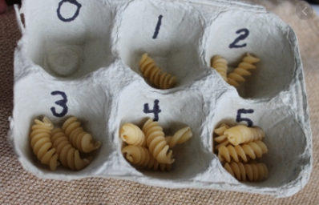

Wednesday 1st April:
Follow the link to the website above and watch the 3rd video in the list: ‘Starting with a Story – Making Collections’. Then click ‘Get the Activity’ to read about your task today:
- Go on a spring time walk and hunt for objects that your child finds interesting.
- Spread the objects out and talk about them.
- Make arrangements with the objects or sort them in to different groups.

Thursday 2nd April:
Follow the link to the website above and watch the 4th video in the list: ‘Starting with a Story – Number or Shape Hunt’. Then click ‘Get the Activity’ to read about your task today:
- Go on a number or shape hunt
- How many different numbers and shapes did you find? Did you spot any that were the same?

Friday 3rd April:
Follow the link to the website above and watch the 5th video in the list: ‘Starting with a Story – Decorating Eggs and More. Then click ‘Get the Activity’ to read about your task today:
- Boil some real eggs until they are hard boiled
- Colour in and decorate them using felt tip pens. Make different patterns such as spots, stripes or zig zags

Literacy

Monday 30th March:
Make a weather chart to show what the spring weather is like each day.
Draw a picture of the weather today and write a word or sentence to go with it.

Tuesday 31st March:
Draw your house and write labels to show the different parts.
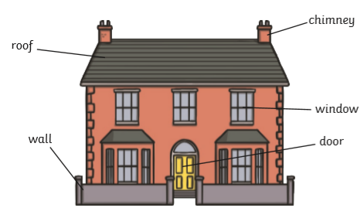

Wednesday 1st April:
Go for a walk with a grown up to look at the signs of spring.
Draw and write about one of the things you saw on your walk.

Thursday 2nd April:
During spring, lots of animals have their babies. Find out the names of these baby animals: duck, pig, sheep, cow and horse. Draw pictures of them and label each baby animal.

Friday 3rd April:
During spring, seeds begin to grow. In the story of Jack and the Beanstalk, Jack’s beans grow in to a magic beanstalk. Tell the story of Jack and the Beanstalk with a grown-up at home. You could even act out the story together!
Here is a link to the story of Jack and the Beanstalk on YouTube (please check the video link before watching it with your child): https://www.youtube.com/watch?v=_VCpAYajmvo

Phonics
In addition to the suggested phonics activities below, we recommend also watching this YouTube video of all the Jolly Phonics sounds daily.
https://www.youtube.com/watch?v=U2HYM9VXz9k

Monday 30th March:
Focus sound: ‘n’
Go on a hunt around the house for things that begin with a ‘n’. Attempt to write the names of some of these objects. Children could also draw pictures.

Tuesday 31st March:
Focus sound: ‘c’ and ‘k’
Go on a hunt around the house for things that begin with ‘c’ or ‘k’. Attempt to write the names of some of these objects. Children could also draw pictures.

Wednesday 1st April:
Focus sound: ‘e’
Go on a hunt around the house for things that begin with ‘e’. Attempt to write the names of some of these objects. Children could also draw pictures.

Thursday 2nd April:
Focus sound: ‘h’
Go on a hunt around the house for things that begin with ‘h’. Attempt to write the names of some of these objects. Children could also draw pictures.

Friday 3rd April:
Focus sound: ‘r’
Go on a hunt around the house for things that begin with ‘r’. Attempt to write the names of some of these objects. Children could also draw pictures.

Wider Curriculum activity suggestions:
Art and Design – Junk Modelling
- Children use recycled materials to make an object of their own choice

Understanding the World – Exploring different materials
- Children explore and sort different materials that they find around the home. Sort into groups such as things that can be recycled and things that cannot.

Understanding the World – Weather and seasonal changes
- Take time to observe the weather each day. You could even record this on a daily weather chart! Look for signs of spring outside such as blossom on trees and flowers growing.

Understanding the World – Technology
- Look around the house for different types of technology, such as things in the kitchen (fridge, oven, digital scales), phone, tablet, hairdryer etc. Discuss how these items are used and how they help with daily life.

Art and Design – Painting and Drawing
- If you have painting or drawing resources, children can create pictures of their own choice. They might choose to do a self-portrait, or draw what they can see outside.

Music
- Make different sounds using objects about the home. You could even try and make your own musical instrument!
- Play along to the nursery rhymes with Mr Tumble on Cbeebies: https://www.bbc.co.uk/cbeebies/watch/something-special-nursery-rhyme-compilation

Art and Design - Construction
- Use your own construction kits (e.g. Lego) or boxes and recycled materials that you have in the home to make a building or a vehicle of your choice.

Physical Development
- Choose one of the Cosmic Yoga videos on YouTube: https://www.youtube.com/user/CosmicKidsYoga
- Kids workout videos with Joe Wicks the Body Coach on YouTube: https://www.youtube.com/watch?v=d3LPrhI0v-w

