The very hungry caterpillar

The very hungry caterpillar in one of our favourite stories in the pre-school and 2 year old room. You can either use your own copy of the book if you wish to do these activities, or there are some lovely animated versions online (I have put all the links below). There are some really lovely activities that we can do using this book as a base for our learning. I have listed a few of these below.
- Share the book or animated film together, talking about what you see.
- Use your book or animated film to count (encouraging your child to join in) all the foods you see.
- Re-tell the story with your child encouraging them to join in with the bits they remember. You and your child could re-tell this story to a teddy or favourite toy.
- You could print out or draw pictures and stick them on lolly sticks or straws to make puppets.
- There is a caterpillar song that we have sang with the children before (I have put two links below). You can join in with this song in various ways. 1) you can sing along
2) you can do small movements to the music using your hands.
3) you can do large movements to the music using your whole body.
- Make your own caterpillars by finger painting using a red fingerprint for the head then green fingerprints for the body. You could make caterpillars of different lengths. When they have dried you could count how many green fingerprints are on each (so your child in hearing counting). For pre school children you could talk about which caterpillar is longer or shorter.
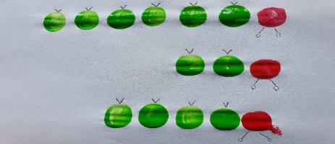
- For pre school children start a pattern (with fingerprints) and encourage them to carry the pattern on.
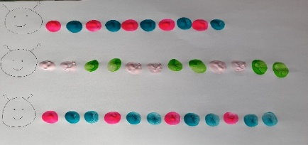
- Write a number and ask your child to put that many fingerprint dots next to it.
- Go outside into your garden and collect sticks, leaves etc and make a collage picture with them. You could talk about how each item feels and looks.
- There are a lot of free print out pictures of the very hungry caterpillar if you google very hungry caterpillar colouring pages and then click on images. Colouring is a lovely activity to do with your children as it develops early pencil control.
- Melody has done a program on caterpillars and butterflies. I have put the link below.
- Use play dough to make some of the food and characters that you find in the book.
- On Friday Chester zoo recorded some footage in the butterfly house. I have put the link below.
- Use 4 coloured circles to make a caterpillar (see picture below) go on a search around your house to find things that match that colour. 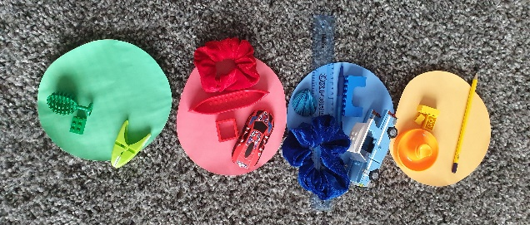
- There are a lot of really nice free resources on twinkl linked to the very hungry caterpillar. They will ask you to sign up to download these resources.
- Cosmic yoga have done a program based around The very hungry caterpillar. All the children have enjoyed joining in with yoga sessions in class. You might want to break this yoga session down as it’s a long one.

Before using any of these links with your child please make sure an adult has watched it first so that you know you are happy with the content.

Animated story
https://www.youtube.com/watch?v=75NQK-Sm1YY

https://www.youtube.com/watch?v=UTlJHDHeZzU this is a good version if you are counting the items on each page.

A tiny caterpillar song
https://www.youtube.com/watch?v=A-zQ82yN68I
https://www.youtube.com/watch?v=owqvHXJKDys

Melody
https://www.bbc.co.uk/iplayer/episode/b063d4c3/melody-series-2-18-little-blue-butterfly

other animated stories involving caterpillars
https://www.youtube.com/watch?v=tYa6OLQHrEc&list=PLJRws_K5_CJvVhDUtoYFOEytIbcdCjKk_
movement and dance
https://www.youtube.com/watch?v=Lkza_tRlNRE
https://www.youtube.com/watch?v=5YPMKtYTkU8
https://www.youtube.com/watch?v=YnuOeG2EpVk you might want to do this video a bit each day because its quite long but the children enjoy doing cosmic yoga at school.

The butterfly house in Chester zoo.
https://www.youtube.com/watch?v=tbtKhpSlXLE&list=PLezrh9gR8RL3kkND8Pz2zOHHZPRk-a2VC&index=4
Twinkl
https://www.twinkl.co.uk/search

