Reception and Pre-school Home Learning Activities –
Week Beginning 27.04.20
Over the week we would like the children to spend their mornings completing the maths, phonics and literacy activities which we have provided. After lunch, they can choose from one of the ‘wider curriculum’ activities, or do something from their own imagination.
To access further online resources, games and activities, we suggest the following websites:
www.bbc.co.uk/cbeebies/radio - CBeebies Radio for listening activities
www.topmarks.co.uk/maths-games - Maths games
www.bbc.co.uk/iplayer/episodes/b08bzfnh/numberblocks - Numberblocks maths videos
www.phonicsplay.co.uk – Online phonics games
Youtube -
- Ollie Tumner - 11am doing a music lesson LIVE
- Mr Thorne Does phonics
- Joe Wicks - LIVE workout 9am

www.storylineonline.net/ - Storyline online do lovely stories of famous people reading stories
www.bbc.co.uk/cbeebies/shows/numberblocks - numberblocks
www.bbc.co.uk/cbeebies/shows/alphablocks - alphablocks
www.sesamestreet.org/ - sesame street for online games, videos and art activities
www.twinkl.co.uk/home-learning-hub - fantastic ideas and activities to support home learning

Maths
Your home learning activities for maths this week can be found on the fantastic White Rose Hub Home Learning page:
https://whiterosemaths.com/homelearning/early-years/
Please complete the activities under the tab – Summer Term Week 2
The learning for the week is based on the stories: ‘The Night Pirates’ and ‘Troll’. Each day there is a video followed by a suggested activity. If the weather is nice, we encourage you to get outside to explore and enjoy maths as much as possible in the fresh air !
We think it’s best for you to follow the link and watch the video each day before doing the activity, but if this isn’t possible then you can still complete the activity without watching the video. The activities for each day have been summarised in the bullet points below.
Monday 27th April:
- Design and make a pirate telescope using recycled materials. Decorate it using a pattern. Can you make a repeating pattern ?
Tuesday 28th April:
- Collect some objects from around your house to ‘walk the plank’. Design and make your own plank and water to fall in ( this could be in the sink, the bath or the paddling pool ! ). Which objects will float and which will sink ?
Wednesday 29th April:
- Set up your own treasure hunt around the house. Use positional language ( forwards, backwards, above, below, in front, behind ) to help give clues to find the treasure.
Thursday 30th April:
- Design and make your own pirate ship which can hold 5 pieces of treasure. What materials could you use to make it float? Maybe you could make more than one ship using different materials (e.g. a cardboard cereal box and a plastic container) to compare what happens.
Friday 1st May:
- Pretend you are a pirate and practise your counting of different coins. If you don’t have coins around the house you could make and cut out some coins to count.

Literacy
This week our literacy will be based around the story ‘Dear Zoo’. A YouTube link to the story is here: www.youtube.com/watch?v=rudDGRQ9QGA
There are also some great games and activities on the story website: www.dearzooandfriends.com
Please make sure an adult checks any video links before sharing them with a child.
Monday 27th April:
Watch the YouTube video of the story ‘Dear Zoo’.
Discuss it after watching. What was your favourite part of the story ? Which was your favourite character and why ? Have you ever visited a zoo or seen these animals before ?
Activity – draw and label your favourite animal in the story
Tuesday 28th April:
Watch the YouTube video of the story ‘Dear Zoo’ again and discuss.
Talk about what other animals might be at the zoo.
Activity – draw and label your own zoo animal which could be added to the story.
Wednesday 29th April:
Watch the YouTube video of the story ‘Dear Zoo’ again and discuss.
Play a memory game to see if you can remember all the animals in the story.
Activity – draw and label as many animals that you can remember from the story as possible. Challenge – can you draw them in the right order ?
Thursday 30th April:
Make your own zoo using craft materials. You could make cages for the animals using boxes and draw pictures of the different animals inside.
Friday 1st May:
Have a look at all of the animals at Chester Zoo on the website: www.chesterzoo.org/our-zoo/animals
Make some animal shadow art. Instructions on how to do it are here: www.chesterzoo.org/schools/resources/how-to-create-animal-shadow-art

Phonics
The Department for Education are launching a fantastic daily phonics lesson for Reception children starting on Monday 27th April. The sessions will be streamed live on the YouTube channel: www.youtube.com/channel/UCP_FbjYUP_UtldV2K_-niWw/featured
We really encourage you to tune in every day to enable your child to benefit from this structured approach to teaching phonics.
Reception phonics lessons will be streamed at 10am. However, if you are unable to tune in live then you can always watch the lesson back at a more convenient time of the day.
We recommend parents to watch these two videos beforehand:
- ‘Handy Guide to our Online Phonics Lessons’ - www.youtube.com/watch?v=u8C8BCB4hvc
- ‘Quick introduction to our Reception Lessons’ - www.youtube.com/watch?v=v8-xnPACzeI
If you are not able to use the lesson, please use the activities below.
Monday 27th April:
Practice saying and recognising the sounds you have learned.
Playing games will help you remember them. Try writing the letters, s. a. t. p. i. n. on small pieces of paper to make flash cards. Lay them letter side down. How quickly can you say all the letters as you turn them over ? Do this every day, do you get quicker ?
You can write the letters to make another set and play matching them or turn them face down to play ‘pairs’, find two the same.
Save your ‘flash cards’ to use tomorrow.
Tuesday 28th April:
Add the letters m. d. g. o. c. k. to your flash cards. Practice recognising them.
Use your flash cards to make the words: pat, pan, pin, pit.
Say a sentence that includes each word e.g. ‘I pat the dog.’
As you make the word, say each letter sound in turn ‘p-a-t pat.’ Make sure you lay them down from left to right.
Write / copy one word. then cover it up and write it again. Do the same for each word.

Phonics
Wednesday 29th April:
Practice your letters. You could play ‘treasure hunt’ by asking someone to hide one set of letters, and you have to find them and shout out the letter sound as you find it. Now you hide them for someone else to find.
Use your letters to make the words ‘sit, sat, tip, tap.’
Make up a sentence for each word and write the words the same as yesterday.
Challenge: Write the sentence, ‘I tap the pans.’ ( remember to use a finger space between each word and finish the sentence with a full stop. )
Thursday 30th April:
Add the letters e. u. r. h. to your flash cards. Practice recognising all of your letters.
Use the letters to make the words: ‘pad, pot, pod.’
Make up a sentence for each word and write the words the same as yesterday.
Friday 1st May:
Practice all the letters. You might like to make up your own game with them.
Complete the sheet below. Look at the pictures. What can you see? Now read the captions.
( Try to sound out the words. )
Match the captions to the pictures. Draw a line to join them.

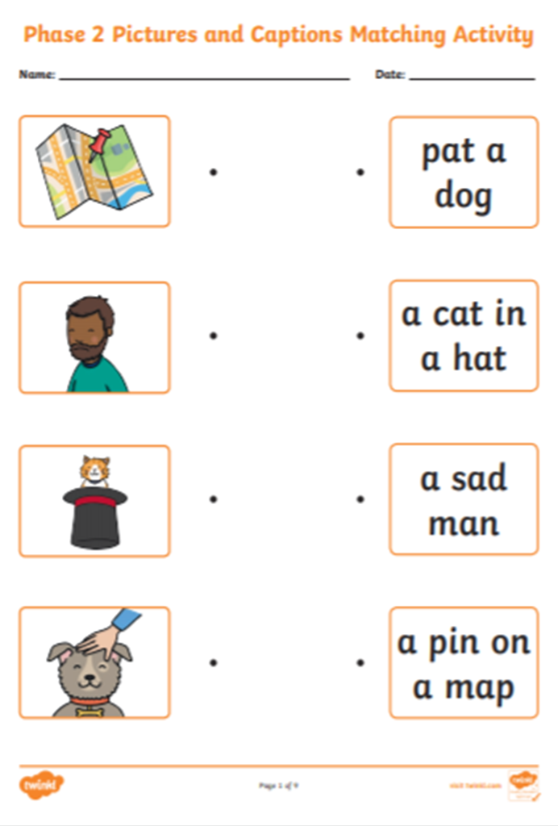

Wider Curriculum activity suggestions:
Art and Design – Play dough - Using bought dough or try to make your own if flour available.
- Make your own animal. This could be real or imaginary. You could use objects to add details-buttons, sticks, leaves, small stones, pipe cleaners, pressing objects into dough to make a pattern. Use either end of a pencil to make spots and holes. Give it a name and take a photo. We would love to see them.
Understanding the World – Exploring different materials
- Children explore and sort different materials that they find around the home. Sort into groups such as things that can be recycled and things that cannot.
- Which materials make a good boat ? Which are not so good ? Why ? Describe what happens.
Understanding the World – Weather and seasonal changes
- Take time to observe the weather each day. You could record this on a daily weather chart ! Look for signs of spring outside such as blossom on trees and flowers growing.
- Have you noticed what is growing ? Draw a picture of a flower. Talk about the different parts of the flower: stem, petals, leaves. How is it the same, or different from another flower ?
- Take a photo of a tree you can see regularly. Take another every month. Does it look the same ? What is different ? Why ?
Understanding the World – Technology
- Look around the house for different types of technology, such as things in the kitchen (fridge, oven, digital scales), phone, tablet, hairdryer etc. Discuss how these items are used and how they help with daily life.
- Take photos of your favourite places at home. Why do you like them ?
- Take a photo of a tree you can see regularly. Take another every month. Does it look the same ? What is different? Why ?
Art and Design – Painting and Drawing
- If you have painting or drawing resources, children can create pictures of their own choice. They might choose to do a self-portrait, or draw what they can see outside.
- If you have crayons, make a colourful rainbow. Explore using a light wash of blue paint over it to make the sky.
- Print using different objects-fruit, vegetables, blocks, Lego, yoghurt pot, hands, feet, potato masher, fork.
- Make a repeated pattern by printing objects e.g. apple, carrot, apple, apple, carrot.
- Use different objects to paint with, sticks, nail brush, tea bag, feather, sponge, fingers, scrunched kitchen roll/newspaper. What could you use as paint ? Mud ? Tea ? Coloured flour paste ? Use your imagination ! ( But please keep safe. )

Music
- Make different sounds using objects about the home. You could even try and make your own musical instrument!
- How many songs about animals can you sing? Make sounds to represent each animal. Try Old McDonald Had a Farm.
- Change the way you sing a song. Sing it softly. Sing loudly. Sing quickly. Sing slowly.
- Play along to the nursery rhymes with Mr Tumble on Cbeebies: www.bbc.co.uk/cbeebies/watch/something-special-nursery-rhyme-compilation
- Don’t forget to watch the programmes from Love Music Trust ( see top of our web page )
Art and Design - Construction
- Use your own construction kits ( e.g. Lego ) or boxes and recycled materials that you have in the home to make a building or a vehicle of your choice.
- Make your own zoo or pet shop. You could make enclosures, cages, pet carrier. What might the animals need in their enclosure ?
Physical Development
- Choose one of the Cosmic Yoga videos on YouTube: www.youtube.com/user/CosmicKidsYoga
- Kids workout videos with Joe Wicks the Body Coach on YouTube: www.youtube.com/watch?v=d3LPrhI0v-w
- Make an obstacle course indoors or outside. ( please make sure your grown up helps you to make sure it is safe. ) Crawl under a table, hop to the chair, jump over a book, balance along a piece of string, bunny hop to the flowers etc.
- How many small objects can you pick up and put in a pot in 10 seconds ? Now only use one hand. Then try the other hand. Can you do it with your toes ? If that was easy try to pick up grains of rice, blades of grass, lentils. Try posting small objects into the top of a bottle. ( make sure they will come out again. ) If you have tweezers, can you use those? Try wearing gloves.
- Cutting. Using scissors to cut out pictures for a collage / to make a card.
- Draw around your hand / foot and cut it out, Colour it in / decorate it.
- Ask if you can help to make a sandwich. What will you need to do before you touch the food? What equipment will you need ? Practice spreading and cutting.
- Fill a bottle using a smaller pot/bottle / lid. Try not to spill any.
- Use a jug to pour out juice when you all need a drink.

