Reception and Pre-school Home Learning Activities –
Week Beginning 08.06.20
Over the week we would like the children to spend their mornings completing the maths, phonics and literacy activities which we have provided. After lunch, they can choose from one of the ‘wider curriculum’ activities, or do something from their own imagination.
To access further online resources, games and activities, we suggest the following websites:
www.bbc.co.uk/cbeebies/radio - CBeebies Radio for listening activities
www.topmarks.co.uk/maths-games - Maths games
www.bbc.co.uk/iplayer/episodes/b08bzfnh/numberblocks - Numberblocks maths videos
www.phonicsplay.co.uk – Online phonics games
Youtube -
- Ollie Tumner - 11am doing a music lesson LIVE
- Mr Thorne Does phonics
- Joe Wicks - LIVE workout 9am

www.storylineonline.net/ - Storyline online do lovely stories of famous people reading stories
www.bbc.co.uk/cbeebies/shows/numberblocks - numberblocks
www.bbc.co.uk/cbeebies/shows/alphablocks - alphablocks
www.sesamestreet.org/ - sesame street for online games, videos and art activities
www.twinkl.co.uk/home-learning-hub - fantastic ideas and activities to support home learning

Maths
Maths activities can be found on the White Rose Hub website: https://whiterosemaths.com/homelearning/early-years/
This week, please complete the activities under the tab – Summer Term Week 7. This week your learning is all based around The Snail and The Whale story.
Each day there is a video followed by a suggested activity. If the weather is nice, we encourage you to get outside to explore and enjoy maths as much as possible in the fresh air!
We think it’s best for you to follow the link and watch the video each day before doing the activity, but if this isn’t possible then you can still complete the activity without watching the video.

Literacy
This week our literacy will be based around the story Sharing a Shell by Julia Donaldson. We hope you enjoy all of the learning activities linked to this lovely book! Maybe you will also notice some links to the text from last week – Snail and the Whale.
Monday 8th June:
Watch and enjoy the video re-telling of Sharing a Shell on YouTube (adults please ensure that you check any videos on YouTube first before sharing them with your child).
https://www.youtube.com/watch?v=3gzIH5e6db0
Discuss the story, thinking about the different things that you liked and why.
Activity – Choose your favourite creature from the story and draw it. Challenge – label your drawing.
Tuesday 9th June:
Re-watch the video of Sharing a Shell to remind yourself of the story. You might also like to watch this Sharing a Shell song by Julia Donaldson as a different way of revising the story: https://www.youtube.com/watch?v=YxbYzI4_DDg
Activity – Identify the rhyming pairs in the story. Have a go at writing or drawing pictures to represent the rhyming words. You might even like to make flashcards of all the rhyming pairs and then playing a game of ‘rhyming snap’ with an adult.
Wednesday 10th June:
Recap on the story and discuss the animals which share their home. Who do you share a home with? Why do you think it is nice to share? Are there other things we can share as well as homes?
Activity – Draw a picture of who you share your house with and label it.
Thursday 11th June:
Recap on the story, noticing the different seaside habitats (rockpool, ocean, beach). Identify which animals live in each of the different habitats. Learn more about coastal habitats on this BBC Bitesize page: https://www.bbc.co.uk/bitesize/topics/zx882hv/articles/zy38wmn
Activity – Draw a picture and write a fact about a coastal habitat.
Friday 12th May:
Recap on the story and the different characters. Make some puppets for each of the characters by using paper/card and lolly-pop sticks. Then have a go at re-telling part of the story using your puppets.

Phonics
We hope that you have been enjoying the daily phonics lessons launched by The Department for Education that started last week. This week we would like you to continue tuning in to these online lessons each day. The sessions will be streamed live on the YouTube channel: https://www.youtube.com/channel/UCP_FbjYUP_UtldV2K_-niWw/featured
We really encourage you to tune in every day to enable your child to benefit from this structured approach to teaching phonics.
Reception phonics lessons will be streamed at 10am. However, if you are unable to tune in live then you can always watch the lesson back at a more convenient time of the day.
We recommend parents to watch these two videos beforehand:
- ‘Handy Guide to our Online Phonics Lessons’ - www.youtube.com/watch?v=u8C8BCB4hvc
- ‘Quick introduction to our Reception Lessons’ - www.youtube.com/watch?v=v8-xnPACzeI
If you are not able to use the lesson, please use the activities below.
Monday 8th June:
Practice saying and recognising the sounds you have learned with your flashcards. Playing games will help you remember them.
Introduce the sound ‘th’ explaining that it is two letters which make one sound.
Write the following words on paper: moth , thin , bath , path and circle the ‘th’ sound. Practice reading each word, saying each sound in turn ‘m-o-th moth’
Make an ‘th’ flashcard to add to your pack so that you can practice it every day.
Practice the sound on the ‘th’ sheet below.

Tuesday 9th June:
Practice saying and recognising the sounds you have learned with your flashcards. Playing games will help you remember them.
Introduce the sound ‘qu’ explaining that it is two letters which make one sound.
Write the following words on paper: quit , queen , quill and circle the ‘qu’ sound. Practice reading each word, saying each sound in turn ‘qu-i-t quit’
Make an ‘qu’ flashcard to add to your pack so that you can practice it every day.
Practice the sound on the ‘qu’ sheet below.

Wednesday 10th June:
Practice saying and recognising the sounds you have learned with your flashcards. Playing games will help you remember them.
Introduce the sound ‘ou’ explaining that it is two letters which make one sound.
Write the following words on paper: loud , shout , mouth and circle the ‘ou’ sound. Practice reading each word, saying each sound in turn ‘l-ou-d loud’
Make a ‘ou’ flashcard to add to your pack so that you can practice it every day.
Practice the sound on the ‘ou’ sheet below.

Thursday 11th June:
Practice saying and recognising the sounds you have learned with your flashcards. Playing games will help you remember them.
Introduce the sound ‘oi’ explaining that it is two letters which make one sound.
Write the following words on paper: soil , boil , join and circle the ‘oi’ sound. Practice reading each word, saying each sound in turn ‘s-oi-l soil’
Make an ‘oi’ flashcard to add to your pack so that you can practice it every day.
Practice the sound on the ‘oi’ sheet below.

Friday 12th June:
Practice saying and recognising the all the sounds you have learned this week with your flashcards. Play different games and focus on any sounds that you are struggling with.
Practice writing words containing these sounds and draw pictures to go with the words. Each time you write a word with these sounds, draw a circle around the new sound.
Challenge – write a sentence with some of your words. Don’t forget a capital letter, finger spaces and a full stop.

‘th’ sheet – Monday 8th June
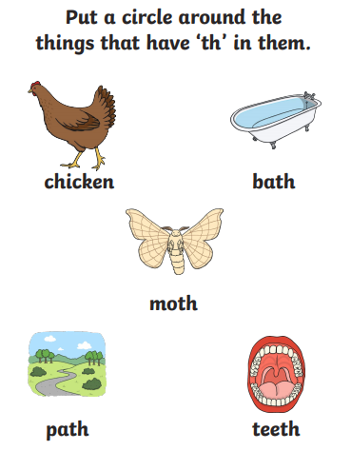

‘qu’ sheet – Tuesday 9th June
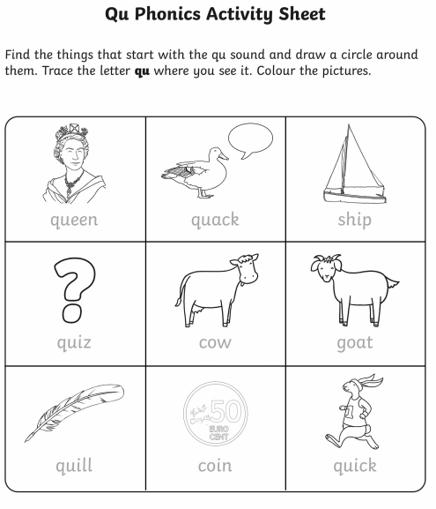

‘ou’ sheet – Wednesday 10th June
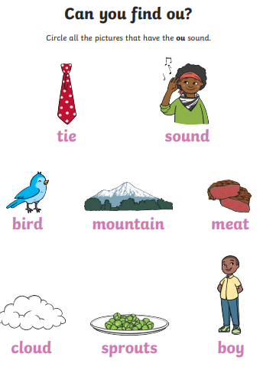

‘oi’ sheet – Thursday 11th June
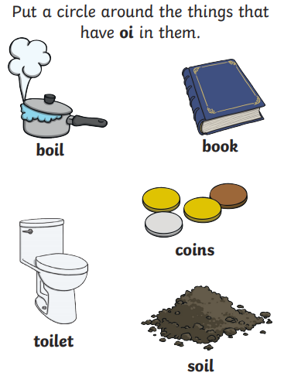

Wider Curriculum activity suggestions:
Personal social and emotional
- Draw or paint a picture of you. Around the edge, draw the things that make you happy. This could be places, people or things. Keep your drawing and put it up somewhere that you see it regularly to remind you of the things which make you happy.
Art and Design – Play dough - Using bought dough or try to make your own if flour available.
- Make your own animal. This could be real or imaginary. You could use objects to add details-buttons, sticks, leaves, small stones, pipe cleaners, pressing objects into dough to make a pattern. Use either end of a pencil to make spots and holes. Give it a name and take a photo. We would love to see them.
Art and Design – Rainbow Hunt
- Go on a nature walk and collect objects of as many different colours as possible. Try to find all colours of the rainbow. When you get home, arrange your objects to look like a rainbow.
Understanding the World – Exploring different materials
- Children explore and sort different materials that they find around the home. Sort into groups such as things that can be recycled and things that cannot.
- Which materials make a good boat? Which are not so good? Why? Describe what happens.
Understanding the World – Weather and seasonal changes
- Take time to observe the weather each day. You could record this on a daily weather chart ! Look for signs of spring outside such as blossom on trees and flowers growing.
- Have you noticed what is growing ? Draw a picture of a flower. Talk about the different parts of the flower: stem, petals, leaves. How is it the same, or different from another flower ?
- Take a photo of a tree you can see regularly. Take another every month. Does it look the same ? What is different ? Why ?
Understanding the World – Technology
- Look around the house for different types of technology, such as things in the kitchen (fridge, oven, digital scales), phone, tablet, hairdryer etc. Discuss how these items are used and how they help with daily life.
- Take photos of your favourite places at home. Why do you like them ?
- Take a photo of a tree you can see regularly. Take another every month. Does it look the same ? What is different? Why ?
Art and Design – Painting and Drawing
- If you have painting or drawing resources, children can create pictures of their own choice. They might choose to do a self-portrait, or draw what they can see outside.
- If you have crayons, make a colourful rainbow. Explore using a light wash of blue paint over it to make the sky.
- Go on a walk to collect different leaves. Use crayons to make leaf rubbings.
- Print using different objects-fruit, vegetables, blocks, Lego, yoghurt pot, hands, feet, potato masher, fork.
- Make a repeated pattern by printing objects e.g. apple, carrot, apple, apple, carrot.
- Use different objects to paint with, sticks, nail brush, tea bag, feather, sponge, fingers, scrunched kitchen roll/newspaper. What could you use as paint ? Mud ? Tea ? Coloured flour paste ? Use your imagination ! ( But please keep safe. )
Music
- Make different sounds using objects about the home. You could even try and make your own musical instrument!
- How many songs about animals can you sing? Make sounds to represent each animal. Try Old McDonald Had a Farm.
- Change the way you sing a song. Sing it softly. Sing loudly. Sing quickly. Sing slowly.
- Play along to the nursery rhymes with Mr Tumble on Cbeebies: www.bbc.co.uk/cbeebies/watch/something-special-nursery-rhyme-compilation
- Don’t forget to watch the programmes from Love Music Trust (see top of our web page)
Art and Design - Construction
- Use your own construction kits ( e.g. Lego ) or boxes and recycled materials that you have in the home to make a building or a vehicle of your choice.
- Make your own zoo or pet shop. You could make enclosures, cages, pet carrier. What might the animals need in their enclosure ?
Physical Development
- Choose one of the Cosmic Yoga videos on YouTube: www.youtube.com/user/CosmicKidsYoga
- Kids workout videos with Joe Wicks the Body Coach on YouTube: www.youtube.com/watch?v=d3LPrhI0v-w
- Make an obstacle course indoors or outside. ( please make sure your grown up helps you to make sure it is safe. ) Crawl under a table, hop to the chair, jump over a book, balance along a piece of string, bunny hop to the flowers etc.
- How many small objects can you pick up and put in a pot in 10 seconds ? Now only use one hand. Then try the other hand. Can you do it with your toes ? If that was easy try to pick up grains of rice, blades of grass, lentils. Try posting small objects into the top of a bottle. ( make sure they will come out again. ) If you have tweezers, can you use those? Try wearing gloves.
- Cutting. Using scissors to cut out pictures for a collage / to make a card.
- Draw around your hand / foot and cut it out, Colour it in / decorate it.
- Ask if you can help to make a sandwich. What will you need to do before you touch the food? What equipment will you need ? Practice spreading and cutting.
- Fill a bottle using a smaller pot/bottle / lid. Try not to spill any.
- Use a jug to pour out juice when you all need a drink.
- Make up your own dance routine. What different shapes and patterns can you make with your body?

