Sandbach Primary Academy Curriculum Map for Mathematics
At Sandbach Primary Academy, we have used the NCETM’s Curriculum Prioritisation materials to map our curriculum for mathematics in a mixed age approach to teaching. Where possible we have aligned the units to allow both year groups to be taught together with the teacher differentiating the small steps within the lesson based on the outcomes of the pre-assessments (example assessment questions - Mathematics Guidance: key stages 1 and 2 June 2020). Some units are planned to extend the learning in the previous year group e.g. Year 3 unit 1 (Adding and subtracting across 10) is extended to adding and subtracting across 10s and 100s in year 4. Where the units do not align, we teach the concepts separately, where the lesson structure is dependent upon the maths being taught, the year groups and the outcomes of the pre-assessments. As a school, we have a range of lesson structures that we use across the school:
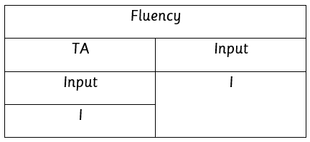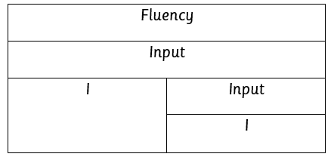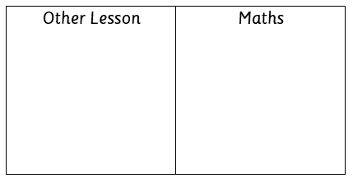
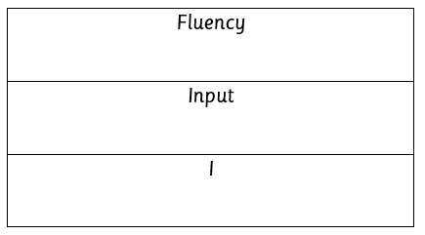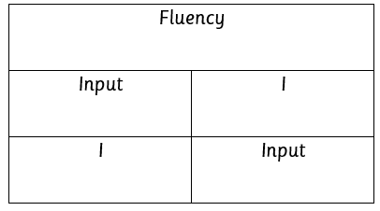
In the following year, careful transit allows teachers to use the map to adjust the sequence of the units (if children need longer on certain units then some units are moved to the following year to allow for depth of learning).
Our Year 1 Mathematics curriculum builds upon the skills and knowledge the children have gained during their time in our EYFS. The children will have developed a strong grounding in number so that they have the building blocks to excel mathematically and a strong base from which the mastery of maths is built. They will have gained a deep understanding of number to 10, including the composition of each number, be able to subitize and know number bonds to 5 and 10. They will have looked at patterns within numbers to 10, including evens and odds and double facts and the pattern of the counting system to 20 and beyond. They will also have looked at quantities up to 10 in different contexts and be able to say when one quantity is greater or less than or the same. They will have been given frequent and varied opportunities to build and apply their understanding through the use of manipulatives, to spot connections, look for patterns and relationships and to develop a ‘have a go’ attitude.

Year 1 and 2 (Mastering Number is used in Year 1 and 2 to develop the fluency from learning in Reception) | Autumn |  |  |  |  | Spring |  |  |  | Summer
 | Y1 unit 1 previous reception experiences and counting within 100 |  | Y1 unit 2 composition of quantities and part-whole relationships | Y1 unit 3 numbers 0 to 5 | Y1 unit 5 numbers 0 to 10 | Y1 unit 6 additive structures | Y1 unit 7 addition and subtraction facts within 10 |  | Y1 unit 8 numbers 0 to 20 | Y1 unit 9 unitising and coin recognition | Y1 unit 4 recognise, compose, decompose and manipulate 2D and 3D shapes | Y1 unit 10 position and direction | Y1 unit 11 time
 | Materials from Weeks 0,1,2 and 3  (C and P) |  | Week 4  (C and P) | Week 7  (C and P) | Weeks 5,6, 9 and 10  Week 4 TP3  (C and P) | Weeks 11,12,13,14  (C and P) | Week 15 TP1  Weeks 17,18,19,20  (Integrated) |  | Weeks 21,22  (Integrated)  Week 23  (C and P) | Weeks 24,25,26,27,28,29,30,31  (C and P)
 | Mastering Number
 | Use Mastering Number materials as Connections and Patterns – not necessarily using all of the steps and ensuring that the concepts are not running ahead of the ones taught in the main lesson.
 | Y2 unit 1 numbers 10 to 100 | Y2 unit 2 calculations within 20 | Y2 unit 3 fluently add and subtract within 10 | Y2 unit 4 addition and subtraction of two-digit numbers (1) | Y2 unit 8 addition and subtraction of two-digit numbers (2) | Y2 unit 5 introduction to multiplication | Y2 unit 6 introduction to division structures | Y2 unit 13 multiplication and division – doubling, halving, quotitive and partitive division | Y2 unit 10 fractions | Y2 unit 9 money | Y2 unit 7 shape | Y2 unit 12 position and direction | Y2 unit 11 time | Y2 unit 14 sense of measure – capacity, volume, mass
Learning in year 1 and 2 is mapped into three terms, no set time is given to a unit of learning (if children need longer on certain units then some units are moved to the following year to allow for depth of learning). Learning is supported using pre-teach and same day intervention.
Year 3 and 4 | Autumn |  |  |  |  | Spring |  |  | Summer
 | Y3 Unit 1  Adding and subtracting across 10 | Y3 Unit 2  Numbers to 1000 |  | Y3 Unit 5  Column addition | Y3 Unit 7  Column subtraction | Y3 Unit 6  2,4,8 times tables | Y3 Unit 3  Right angles | Y3 Unit 4  Manipulating the additive relationship and securing mental calculation | Y3 Unit 8  Unit fractions |  |  | Y3 Unit 9  Non-unit fractions | Y3 Unit 10  Parallel and perpendicular sides in polygons |  | Y3 Unit 11  Time
 | *Counting and subtracting across 10s and 100s | Y4 Unit 2  Numbers to 10,000 | Y4 Unit 3  Perimeter | Y4 Unit 1 Review of column addition and subtraction |  | Y4 Unit 4  3,6,9 times tables | Y4 Unit 5  7 times tables and patterns | Y4 Unit 6  Understanding and manipulating multiplicative relationships | Y4 Unit 12  Division with remainders Y4 | Unit 8  Review of fractions | Y4 Unit 9  Fraction greater than 1 |  | Y4 unit 7  Coordinates | Y4 Unit 10  Symmetry in 2D shapes | Y4 Unit 11  Time
*For Mastering Number, at the beginning of the autumn term the concepts are similar (subitising, bonds in 5 and then 10) we aim to combine theses concepts carefully making sure that that it doesn't take up too much time. Alternatively, we base the C&P mainly on the Y1 materials with a few bits added from the Y2 where appropriate and not taking up too much time to plan or in the lesson. On occasions, we carefully select sections from the MN materials
fairly randomly as C and P as well as looking back to other concepts such as counting.
Learning in year 3 and 4 is mapped into three terms, no set time is given to a unit of learning (if children need longer on certain units then some units are moved to the following year to allow for depth of learning). Learning is supported using pre-teach and same day intervention.

Year 5 and 6 | Autumn |  |  |  |  |  | Spring |  |  |  |  | Summer
 | Y5 unit 1  Decimal fractions | *Y6 unit 1 calculating using knowledge of structures | *Y6 unit 2 Multiples of 1,000 | *Y6 unit 3 Numbers to 10,000,000 | *Year 5 unit 2 money | Year 5 unit 3 negative number | Year 5 unit 4 short multiplication and short division | Year 5 unit area and scaling | Year 5 unit 6 calculating with decimal fractions | Year 5 unit 7 factors, multiples and primes | Year 5 unit 8 fractions | Year 5 unit 9 converting units | Year 5 unit 10 angles |  | Revisit units as an outcome of assessments
 |  |  |  |  |  |  | Year 6 unit 5 multiplication and division | Year 6 unit 6 area, perimeter, position and direction |  |  | Year 6 unit 7 fractions and percentages | Year 6 unit 4 draw, compose and decompose shapes | SATS | Y6 unit 8 statistics | Y6 unit ratio and proportion | Y6 unit 10 calculating using knowledge of structures | Y6 unit 11 solving problems with 2 unknowns | Y6 unit 12 order of operations | Y6 unit 13 mean average
Learning in year 5 and 6 is mapped into three terms, no set time is given to a unit of learning. *When teaching the units in the autumn term, the number range is differentiated for the children based on the outcomes of the pre-assessments. Learning is supported using pre-teach and same day intervention.

