Year: 3/4 A | Autumn 1 | Autumn 2 | Spring 1 | Spring 2 | Summer 1 | Summer 2
Book  (Main Driver Text) | 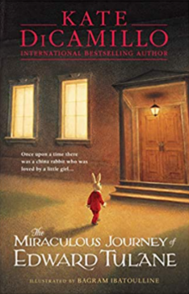  Miraculous Journey of Edward Tullane | 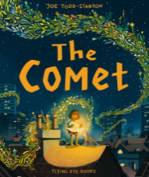  The Comet | Keep off the Tracks  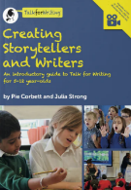  Moon Juice  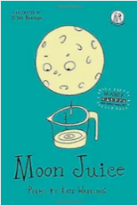 | Cinderella of the Nile  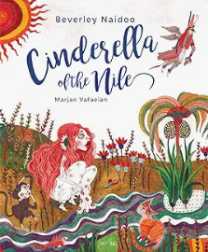 | 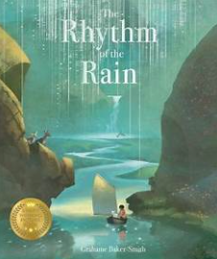  Rhythm of the Rain  Water | Charging About: The Story of  Electricity  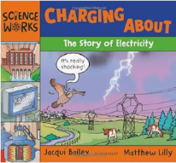  Greek Myths - Midas  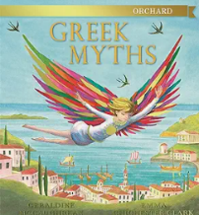
Theme | Empathy/Kindness | Growing and Changing | Growing and changing | Resilience  Egyptians | Water/Rivers | Ancient Greece
Literary form | Narrative | Narrative | Narrative  Poetry | Narrative | Classic fiction | Non-fiction  Myth
Writing outcome | Narrative Retell  Letter - recount  Non-chron report | Diary entry  Poetry – verbs/list  Narrative retell | Retell warning story using tfw then innovate  Setting description (pg.83 TfW) | Narrative wish story – The King of the Fishes  Retell of Cinderella of the Nile with innovation | Recount of residential  Persuasive letter  Descriptive/kennings poetry | Non chron – electricity or simple explanation  Greek myth – retell (wishing story)  Encyclopaedia excerpt
Composition | Year 3  Plan:  • discuss writing similar to that which they are planning to write in order to understand and learn from its structure, vocabulary and grammar  • plan or say out loud what they are going to write about, including writing based on personal experiences  • write down ideas, and/or key words, technical vocabulary and phrases  • compose and rehearse sentences orally, including dialogue, developing vocabulary and sentence structure choices (National Curriculum English Appendix 2)  Draft and write:  • begin to develop the events in a narrative sequence  • begin to include language that is more likely to be found in written texts rather than spoken language  • include dialogue within story writing and begin to use this to reveal detail about character  • use some detail in the description of setting and characters’ feelings or motives  • write in a variety of genres and forms, including writing for real purposes and audiences  • begin to select and use forms and vocabulary appropriate to the purpose / reader  • assemble information on a subject and turn notes into sentences  • include the use of devices to organise writing  • prepare a range of different forms of poetry to read aloud and perform  • write poetry using the features of poetic forms studied  • include a structured sequence of events using a range of conjunctions and adverbs (see spag section for detail of year group expectations)  • begin to use figurative language  • select words for effect from a range provided. When selecting words and phrases for effect, children should be encouraged to consider the needs of the reader and/or the purpose of the text. Reading age-appropriate texts and discussing examples from these will support understanding and application. (see vocabulary / grammar section for detail of year group expectations)  • begin to use a variety of sentence structures. When choosing sentence structures, children should be encouraged to consider the effect on their audience. Reading age-appropriate texts and discussing examples from these will support understanding and application. (see vocabulary / grammar section for detail of year group expectations)  • ensure relevant details are included in both narrative and non-fiction writing e.g. barn owl, baby barn owl, snowy owl. They crossed a little bridge in a small valley full of tiny things. The eldest princess was too proud to answer.  • begin to use paragraphs to group related materials  Evaluate and edit:  • proof read for spelling, grammar and punctuation errors  • re-read to check that their writing makes sense, that tenses are consistent and that pronouns are used accurately  • begin to evaluate and edit the effectiveness of their own and others’ writing and suggest improvements.  • begin to propose changes to vocabulary, punctuation, spelling and grammar  • read aloud their own writing, to a group or the whole class, using the appropriate intonation and controlling the tone and volume so that the meaning is clear.  Year 4  Plan:  • Discuss writing similar to that which they are planning to write in order to understand and learn from its structure, vocabulary and grammar  • discuss ideas for writing, beginning to make personal choices when planning  • write down ideas, and/or key words, technical vocabulary and phrases  • rehearse sentences orally, including dialogue, developing vocabulary and sentence structure choices (National Curriculum English Appendix 2)  Draft and write:  • write narratives, developing the detail across the sequence of events  • include language that is more likely to be found in written texts rather than spoken language  • begin to develop mood and atmosphere, including through dialogue between characters  • describe characters both physically and through their actions and speech  • include setting descriptions across a text  • write in a variety of genre and forms, using the appropriate form / features of the genre for audience and purpose  • organise or categorise information based on notes from several sources  • in non-narrative material, use simple organisational devices  • prepare a range of different forms of poetry to read aloud and perform  • write poetry using the features of poetic forms studied  • sequence events clearly and show how one event leads to another, using appropriate conjunctions and adverbials (see spag section for detail)  • include descriptive detail and figurative language to make writing more vivid  • choose words and phrases for effect When selecting words and phrases for effect, children should be encouraged to consider the needs of the reader and/or the purpose of the text. Reading age-appropriate texts and discussing examples from these will support understanding and application. (see vocabulary / grammar section for detail of year group expectations)  • begin to explore the effect of different sentence structures in their writing, for example by considering the effect of changing the order of the information on the reader: When choosing sentence structures, children should be encouraged to consider the effect on their audience. Reading age-appropriate texts and discussing examples from these will support understanding and application (see vocabulary / grammar section for detail of year group expectations)  • begin to consider the reader when adding detail in both narrative and non-fiction writing  • use paragraphs to organise ideas around a theme in non-fiction forms  • use adverbials to connect one paragraph to another e.g. The next morning… Every day …But suddenly …  • begin to use paragraphs to indicate changes in setting, character and time in a narrative  Evaluate and edit:  • proof read for spelling, grammar and punctuation errors  • re-read to check that their writing makes sense, that tenses are consistent and that pronouns are used accurately  • evaluate and edit the effectiveness of their own and others’ writing and suggest improvements.  • propose changes to vocabulary, punctuation, spelling and grammar  • read aloud their own writing, to a group or the whole class, using the appropriate intonation and controlling the tone and volume so that the meaning is clear
Grammar | Year 3  • use single clause sentences  • and multi-clause sentences using coordinating conjunctions  • use some multi-clause sentences using subordinating conjunctions  • use the full range of punctuation taught across KS1 to demarcate sentences, including commas in lists and apostrophes for singular possession  • use inverted commas to punctuate direct speech  • use commas in lists and begin to use them to demarcate clauses  • express time, place and cause using conjunctions  • begin to expand noun phrases in different ways, for example by adding prepositional phrases  • use some features of standard English e.g .because not coz; he did not he done  • learn the grammar for Y3 from English Appendix 2  • use the present and past tenses correctly and consistently  • use the present perfect form of verbs instead of the simple past  • use and understand the grammatical terminology found in English Appendix 2 in discussing their writing and reading  Year 4  • use single clause sentences  • and multi-clause sentences using coordinating conjunctions  • and multi-clause sentences using subordinating conjunctions  • use the full range of punctuation taught across KS1 to demarcate sentences, including commas in lists and apostrophes for singular possession  • use inverted commas and other punctuation to indicate direct speech i.e. a comma after the reporting clause; end punctuation within inverted commas  • use a new line for a new speaker when writing direct speech  • use apostrophes to mark plural possession e.g. the girls’ names Polar bears’ fat keeps them warm in the sea.  • use commas to demarcate items in a list, clauses, and phrases  • express time, place and cause using conjunctions  • use fronted adverbials  • use commas after fronted adverbials  • use a variety of expanded noun phrases  • use Standard English forms for verb inflections instead of local spoken forms e.g. we were instead of we was, or I did instead of I done  • learn the grammar for Y4 from English Appendix 2  • maintain the use of the present and past tenses correctly and consistently  • use the present perfect form of verbs in contrast to the past tense  • select appropriate pronoun or noun within and across sentences to aid cohesion and avoid repetition e• use and understand the grammatical terminology found in English Appendix 2 in discussing their writing
Handwriting | Year 3  • begin to use the diagonal and horizontal strokes that are needed to join letters and understand which letters, when adjacent to one another, are best left un-joined  • increase the legibility, consistency and quality of handwriting e.g. by ensuring that the down strokes of letters are parallel and equidistant; that lines of writing are spaced sufficiently so that the ascenders and descenders of letters do not touch  Year 4  • secure the use of the diagonal and horizontal strokes that are needed to join letters and understand which letters, when adjacent to one another, are best left un-joined  • increase the legibility, consistency and quality of handwriting e.g. by ensuring that the down strokes of letters are parallel and equidistant; that lines of writing are spaced sufficiently so that the ascenders and descenders of letters do not touch
Transcription | Year 3  • write from memory simple sentences, dictated by the teacher, that include words and punctuation taught so far  • use the first two or three letters of a word to check its spelling in a dictionary  • spell most words relating to the statements from previous year groups correctly, after independent proof-reading  • spell some words relating to the Y3/4 curriculum statements and word lists correctly, after independent proof-reading  Year 4  • write from memory simple sentences, dictated by the teacher, that include words and punctuation taught so far  • use the first two or three letters of a word to check its spelling in a dictionary  • spell most words relating to the statements from previous year groups correctly, after independent proof-reading  • spell most words relating to the Y3/4 curriculum statements and word lists correctly, after independent proof-reading
Cross curricular reference  (Geography, history, science) | Ancient Sumer  The Indus Valley  The Shang Dynasty of China Ancient | UK Cities  Animals including humans | Egypt  Animals including humans | UK Settlement and Land-use  States of Matter | Ancient Greece  Light | The Water Cycle  Rivers  Sound

Year: 3/4 B | Autumn 1 | Autumn 2 | Spring 1 | Spring 2 | Summer 1 | Summer 2
Book  (Main Driver Texts) | 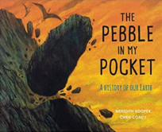  The Pebble in my Pocket  The Secrets of Stonehenge  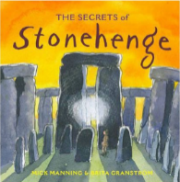 | The Steadfast Tin Soldier  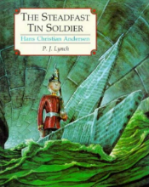  The Robot and the Bluebird  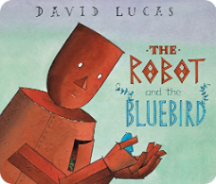 | Blue John  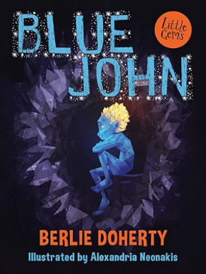 | The Tear Thief (f)  The Language of Cat (p)  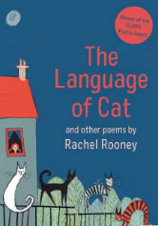 | Hermelin: The Detective Mouse  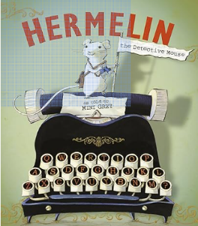  Pie Corbett – The Old Warehouse (pg.132) | 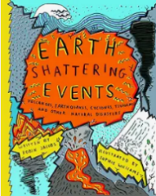  Earth Shattering Events  Bob Cox – Colour Your World (pg.43) What is Pink?
Theme | Stone Age | Overcoming fear | Light and Dark | Emotional authenticity  Moral dilemmas  Time  family | Challenging stereotypes | Extreme Earth
Literary form | Narrative non-fiction | Narrative | Narrative | Narrative  Poetry | Classic Fiction | Non-fiction
Writing outcomes | Information text  Diary of a pebble  Book blurb | Retell  Innovation  Christmas Poetry (haiku) | Retell  Letters writing in role  Poetry (descriptive; figurative language) | Biased argument  Job application: tear thief  Innovating to create a modern fairytale ‘A Smile Giver’ | Writing an ‘Unsung Hero Award’  Innovation of a warning story | Non-chron or Encyclopaedia about volcanoes  Diary entry  Poetry
Composition | Year 3  Plan:  • discuss writing similar to that which they are planning to write in order to understand and learn from its structure, vocabulary and grammar  • plan or say out loud what they are going to write about, including writing based on personal experiences  • write down ideas, and/or key words, technical vocabulary and phrases  • compose and rehearse sentences orally, including dialogue, developing vocabulary and sentence structure choices (National Curriculum English Appendix 2)  Draft and write:  • begin to develop the events in a narrative sequence  • begin to include language that is more likely to be found in written texts rather than spoken language  • include dialogue within story writing and begin to use this to reveal detail about character  • use some detail in the description of setting and characters’ feelings or motives  • write in a variety of genres and forms, including writing for real purposes and audiences  • begin to select and use forms and vocabulary appropriate to the purpose / reader  • assemble information on a subject and turn notes into sentences  • include the use of devices to organise writing  • prepare a range of different forms of poetry to read aloud and perform  • write poetry using the features of poetic forms studied  • include a structured sequence of events using a range of conjunctions and adverbs (see spag section for detail of year group expectations)  • begin to use figurative language  • select words for effect from a range provided. When selecting words and phrases for effect, children should be encouraged to consider the needs of the reader and/or the purpose of the text. Reading age-appropriate texts and discussing examples from these will support understanding and application. (see vocabulary / grammar section for detail of year group expectations)  • begin to use a variety of sentence structures. When choosing sentence structures, children should be encouraged to consider the effect on their audience. Reading age-appropriate texts and discussing examples from these will support understanding and application. (see vocabulary / grammar section for detail of year group expectations)  • ensure relevant details are included in both narrative and non-fiction writing e.g. barn owl, baby barn owl, snowy owl. They crossed a little bridge in a small valley full of tiny things. The eldest princess was too proud to answer.  • begin to use paragraphs to group related materials  Evaluate and edit:  • proof read for spelling, grammar and punctuation errors  • re-read to check that their writing makes sense, that tenses are consistent and that pronouns are used accurately  • begin to evaluate and edit the effectiveness of their own and others’ writing and suggest improvements.  • begin to propose changes to vocabulary, punctuation, spelling and grammar  • read aloud their own writing, to a group or the whole class, using the appropriate intonation and controlling the tone and volume so that the meaning is clear.  Year 4  Plan:  • Discuss writing similar to that which they are planning to write in order to understand and learn from its structure, vocabulary and grammar  • discuss ideas for writing, beginning to make personal choices when planning  • write down ideas, and/or key words, technical vocabulary and phrases  • rehearse sentences orally, including dialogue, developing vocabulary and sentence structure choices (National Curriculum English Appendix 2)  Draft and write:  • write narratives, developing the detail across the sequence of events  • include language that is more likely to be found in written texts rather than spoken language  • begin to develop mood and atmosphere, including through dialogue between characters  • describe characters both physically and through their actions and speech  • include setting descriptions across a text  • write in a variety of genre and forms, using the appropriate form / features of the genre for audience and purpose  • organise or categorise information based on notes from several sources  • in non-narrative material, use simple organisational devices  • prepare a range of different forms of poetry to read aloud and perform  • write poetry using the features of poetic forms studied  • sequence events clearly and show how one event leads to another, using appropriate conjunctions and adverbials (see spag section for detail of year group expectations)  • include descriptive detail and figurative language to make writing more vivid  • choose words and phrases for effect When selecting words and phrases for effect, children should be encouraged to consider the needs of the reader and/or the purpose of the text. Reading age-appropriate texts and discussing examples from these will support understanding and application. (see vocabulary / grammar section for detail of year group expectations)  • begin to explore the effect of different sentence structures in their writing, for example by considering the effect of changing the order of the information on the reader: When choosing sentence structures, children should be encouraged to consider the effect on their audience. Reading age-appropriate texts and discussing examples from these will support understanding and application (see vocabulary / grammar section for detail of year group expectations)  • begin to consider the reader when adding detail in both narrative and non-fiction writing  • use paragraphs to organise ideas around a theme in non-fiction forms  • use adverbials to connect one paragraph to another e.g. The next morning… Every day …But suddenly …  • begin to use paragraphs to indicate changes in setting, character and time in a narrative  Evaluate and edit:  • proof read for spelling, grammar and punctuation errors  • re-read to check that their writing makes sense, that tenses are consistent and that pronouns are used accurately  • evaluate and edit the effectiveness of their own and others’ writing and suggest improvements.  • propose changes to vocabulary, punctuation, spelling and grammar  • read aloud their own writing, to a group or the whole class, using the appropriate intonation and controlling the tone and volume so that the meaning is clear
Grammar | Year 3  • use single clause sentences  • and multi-clause sentences using coordinating conjunctions  • use some multi-clause sentences using subordinating conjunctions  • use the full range of punctuation taught across KS1 to demarcate sentences, including commas in lists and apostrophes for singular possession  • use inverted commas to punctuate direct speech  • use commas in lists and begin to use them to demarcate clauses  • express time, place and cause using conjunctions  • begin to expand noun phrases in different ways, for example by adding prepositional phrases  • use some features of standard English e.g .because not coz; he did not he done  • learn the grammar for Y3 from English Appendix 2  • use the present and past tenses correctly and consistently  • use the present perfect form of verbs instead of the simple past  • use and understand the grammatical terminology found in English Appendix 2 in discussing their writing and reading  Year 4  • use single clause sentences  • and multi-clause sentences using coordinating conjunctions  • and multi-clause sentences using subordinating conjunctions  • use the full range of punctuation taught across KS1 to demarcate sentences, including commas in lists and apostrophes for singular possession  • use inverted commas and other punctuation to indicate direct speech i.e. a comma after the reporting clause; end punctuation within inverted commas  • use a new line for a new speaker when writing direct speech  • use apostrophes to mark plural possession e.g. the girls’ names Polar bears’ fat keeps them warm in the sea.  • use commas to demarcate items in a list, clauses, and phrases  • express time, place and cause using conjunctions  • use fronted adverbials  • use commas after fronted adverbials  • use a variety of expanded noun phrases  • use Standard English forms for verb inflections instead of local spoken forms e.g. we were instead of we was, or I did instead of I done  • learn the grammar for Y4 from English Appendix 2  • maintain the use of the present and past tenses correctly and consistently  • use the present perfect form of verbs in contrast to the past tense  • select appropriate pronoun or noun within and across sentences to aid cohesion and avoid repetition  • use and understand the grammatical terminology found in English Appendix 2 in discussing their writing
Handwriting | Year 3  • begin to use the diagonal and horizontal strokes that are needed to join letters and understand which letters, when adjacent to one another, are best left un-joined  • increase the legibility, consistency and quality of handwriting e.g. by ensuring that the down strokes of letters are parallel and equidistant; that lines of writing are spaced sufficiently so that the ascenders and descenders of letters do not touch  Year 4  • secure the use of the diagonal and horizontal strokes that are needed to join letters and understand which letters, when adjacent to one another, are best left un-joined  • increase the legibility, consistency and quality of handwriting e.g. by ensuring that the down strokes of letters are parallel and equidistant; that lines of writing are spaced sufficiently so that the ascenders and descenders of letters do not touch
Transcription | Year 3  • write from memory simple sentences, dictated by the teacher, that include words and punctuation taught so far  • use the first two or three letters of a word to check its spelling in a dictionary  • spell most words relating to the statements from previous year groups correctly, after independent proof-reading  • spell some words relating to the Y3/4 curriculum statements and word lists correctly, after independent proof-reading  Year 4  • write from memory simple sentences, dictated by the teacher, that include words and punctuation taught so far  • use the first two or three letters of a word to check its spelling in a dictionary  • spell most words relating to the statements from previous year groups correctly, after independent proof-reading  • spell most words relating to the Y3/4 curriculum statements and word lists correctly, after independent proof-reading
Cross curricular reference | Stone Age  Rocks and Soils | Europe | Iron Age  Forces and Magnets | Europe and Local Study  Electricity | Roman Empire  Plants | Volcanoes  Living things and their Habitats

