Year: 5/6 A | Autumn 1 | Autumn 2 | Spring 1 | Spring 2 | Summer 1 | Summer 2
Book  (Main Driver Text) | Beowulf  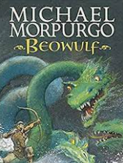  Kevin Crossley-Holland | 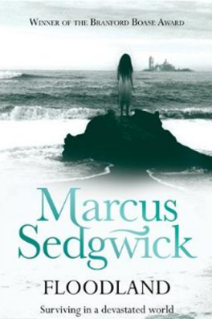  Floodland | The Sleeper and the Spindle  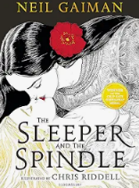  New and Collected Poems for Children  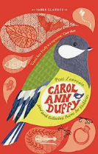 | The Brockenspectre  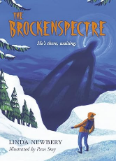  Survivors  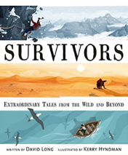 | The Matchbox Diary  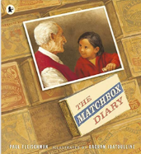  A Story Like the Wind  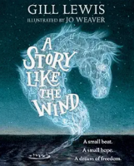 | Kensuke’s Kingdom  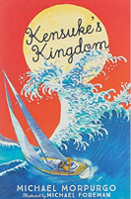  The Lady of Shallot (p)  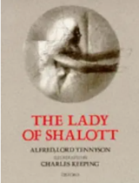
Author | Michael Morpurgo | Marcus Sedgwick | Neil Gaiman  Carol Ann Duffy | Linda Newbery  David Long | Paul Fleischman  Gill Lewis | Michael Morpurgo  Tennyson/Keeping
Theme | Anglo-Saxons | Coastal settings/water | Fairytales and myths | Survival | Migration | Island/water settings
Literary form | Classic fiction | Modern fiction (dystopian) | Narrative (myths)  Poetry | Fiction  Non-fiction | Picture Book  Fiction | Narrative (adventure)
Linked texts | Monster Slayer  Anglo Saxon Boy (f)  The Genius of the Anglo-Saxons (nf)  Women and Children in Anglo-Saxon Times (nf)  The Buried Crown (f)  Beowulf – Seamus Heaney (p)  Between Worlds | Malamander (f)  Town Is By the Sea (pb)  Flotsam (pb)  Eastbourne (p) – Joseph Coelho (clpe)  Corey’s Rock  The Lost Thing  The Dam  The Giant’s Necklace | Straw into Gold  Blackberry Blue  Odd and the Frost Giants  Arthur and the Golden Rope  Viking Boy  How to be a Viking  Viking Longship  Norse Myths – Tales of Odin, Thor and Loki  How to train your Dragon | My Side of the Mountain (f)  Highest Mountain, Deepest Ocean (nf)  Mountains of the World (nf)  When the Mountains Roared (f) | King of the Sky  The Journey  The Boy at the Back of the Class  Leaf  No Ballet Shoes in Syria  Windrush Child poem  The Day War Came  Story of the Windrush  On the Move: Poems about Migration  Boy Giant | Island  The Tempest  Darwin’s Dragons  History VIPs: Charles Darwin  On the Origin of the Species - Radeva
Reading objectives | Word Reading:  Pupils should be taught to:  • use strategies such as recognising syllables /phonemes to decode new or unfamiliar words  • focus on all the letters in unfamiliar words so that they do not, for example, read ‘invitation’ for ‘imitation’ simply because they might be more familiar with the first word  • re-read, as needed to take account of especially challenging word order and phrasing  • read most words effortlessly and with increasing automaticity  • test out different plausible pronunciations for less familiar words  • [children should be able to read further exception words independently. If they are not able to do so, please refer to previous year groups]  • apply their growing knowledge of root words, prefixes and suffixes (morphology and etymology) as listed in English appendix 1, both to read aloud and to understand the meaning of new words that they meet  • read longer words, using syllable boundaries where needed  • [children should be able to read and understand words with contractions independently. If they are not able to do so, please refer to KS1]  • read aloud unfamiliar words or challenging sections of text, where needed, to support accuracy and automaticity  • re-read words or challenging sections of text to ensure understanding through fluency  • read age-appropriate texts fluently (including pausing appropriately, reading in phrases, responding to punctuation)  Comprehension:  Pupils should be taught to:  • Maintain positive attitudes to reading and understanding of what they read  • Understand what they read  • Discuss and evaluate how authors use language, including figurative language, considering the impact on the reader  • Retrieve, record and present information from non-fiction  • Distinguish between statements of fact and opinion  • Provide reasoned justification for their views  • Participate in discussions about books that are read to them and those they can read for themselves, building on their own and others’ ideas and challenging views courteously  • Explain and discuss their understanding of what they have read, including through formal presentations and debates, maintaining a focus on the topic and using notes where necessary
Cross curricular reference | Anglo-Saxons  Animals including Humans | UK Coasts  Animals including Humans | Vikings  Electricity | UK Mountains | Mayan civilisation  Light | Europe – Economic Activity  Evolution and Inheritance

Year: 5/6 B | Autumn 1 | Autumn 2 | Spring 1 | Spring 2 | Summer 1 | Summer 2
Book  (Main Driver Text) | Stay Where you are and Then Leave  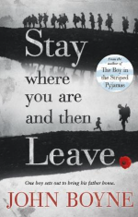  Poems from the First World War | Clockwork  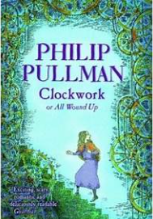 | 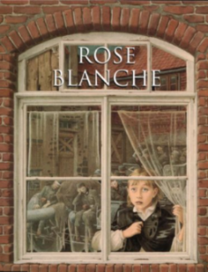  Rose Blanche | 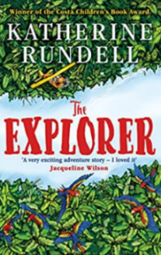  The Explorer | 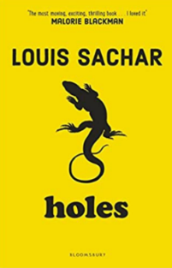  Holes | 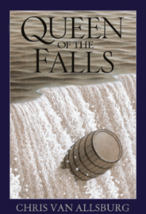  Queen of the Falls
Author | John Boyne | Philip Pullman | Ian McEwan | Katherine Rundell | Louis Sachar | Chris Van Allsberg
Theme | WW1 | Horror/Suspense | WW2 | Adventure/South America | Crime and Punishment | North America
Literary form | Narrative  Poetry | Narrative | Picture Book | Narrative | Narrative | Picturebook
Linked texts  Picture books, poetry, Bob Cox extracts etc. | Armistice Runner  War Horse  Soldier Boy  Archie’s War  Line of Fire – graphic novel  History through poetry – WW1  What are we fighting for?  The Silver Donkey  Where the Poppies Now Grow | Crater Lake  Room 13  Malamander  A Ghastly Waxwork (Bob Cox)  Woman in White – Wilkie Collins  The Dream Snatcher  The Graveyard Book  The Viewer | Letters from the Lighthouse  D Day Dog  In Flanders Field  The Day War Came  The Lion and the Unicorn  Anne Frank – Josephine Poole  My Secret War Diary  The Silver Sword | Journey to the River Sea  Survivors – The Girl Who Fell from the Sky  The Tyger  Trash  The Great Kapok Tree | The Highwayman  Treason  The Adventures of Robin Hood  High-Rise Mystery  To be or not to Be from Hamlet (Blank verse) | The Good Thieves – Katherine Rundell  Wonderstruck  The Boy who Biked the World – Part 2
Reading objectives | Word Reading:  Pupils should be taught to:  • use strategies such as recognising syllables /phonemes to decode new or unfamiliar words  • focus on all the letters in unfamiliar words so that they do not, for example, read ‘invitation’ for ‘imitation’ simply because they might be more familiar with the first word  • re-read, as needed to take account of especially challenging word order and phrasing  • read most words effortlessly and with increasing automaticity  • test out different plausible pronunciations for less familiar words  • [children should be able to read further exception words independently. If they are not able to do so, please refer to previous year groups]  • apply their growing knowledge of root words, prefixes and suffixes (morphology and etymology) as listed in English appendix 1, both to read aloud and to understand the meaning of new words that they meet  • read longer words, using syllable boundaries where needed  • [children should be able to read and understand words with contractions independently. If they are not able to do so, please refer to KS1]  • read aloud unfamiliar words or challenging sections of text, where needed, to support accuracy and automaticity  • re-read words or challenging sections of text to ensure understanding through fluency  • read age-appropriate texts fluently (including pausing appropriately, reading in phrases, responding to punctuation)  Comprehension:  Pupils should be taught to:  • Maintain positive attitudes to reading and understanding of what they read  • Understand what they read  • Discuss and evaluate how authors use language, including figurative language, considering the impact on the reader  • Retrieve, record and present information from non-fiction  • Distinguish between statements of fact and opinion  • Provide reasoned justification for their views  • Participate in discussions about books that are read to them and those they can read for themselves, building on their own and others’ ideas and challenging views courteously  • Explain and discuss their understanding of what they have read, including through formal presentations and debates, maintaining a focus on the topic and using notes where necessary
Cross curricular reference | Climate Zones and biomes  WW1 | WW2  Forces | South America  Living things and their Habitats | Living things and their Habitats | North America  Earth and Space - NASA | Properties and changes of material

